Assignment 7
PNR: 260740150018
Name: PRATIK SUNIL ABHANG

1. Standard ACL - Block One Host
Question: Configure a Standard ACL to block a particular host from accessing all connected devices of the second router.
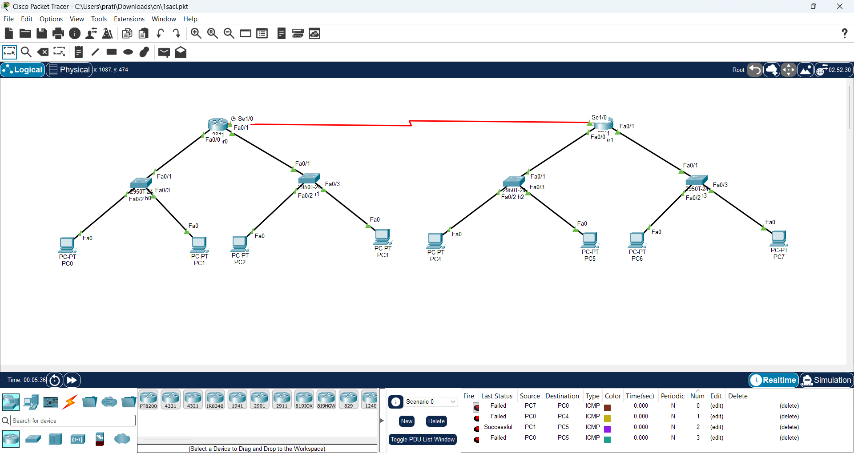
Commands
! Configure on Router1
access-list 10 deny host 192.168.10.10
access-list 10 permit any
interface se1/0
ip access-group 10 in
exit
end
write
Check / Test
show access-lists
show ip interface se1/0
! From PC0:
ping 192.168.30.10
ping 192.168.40.10

Screenshot
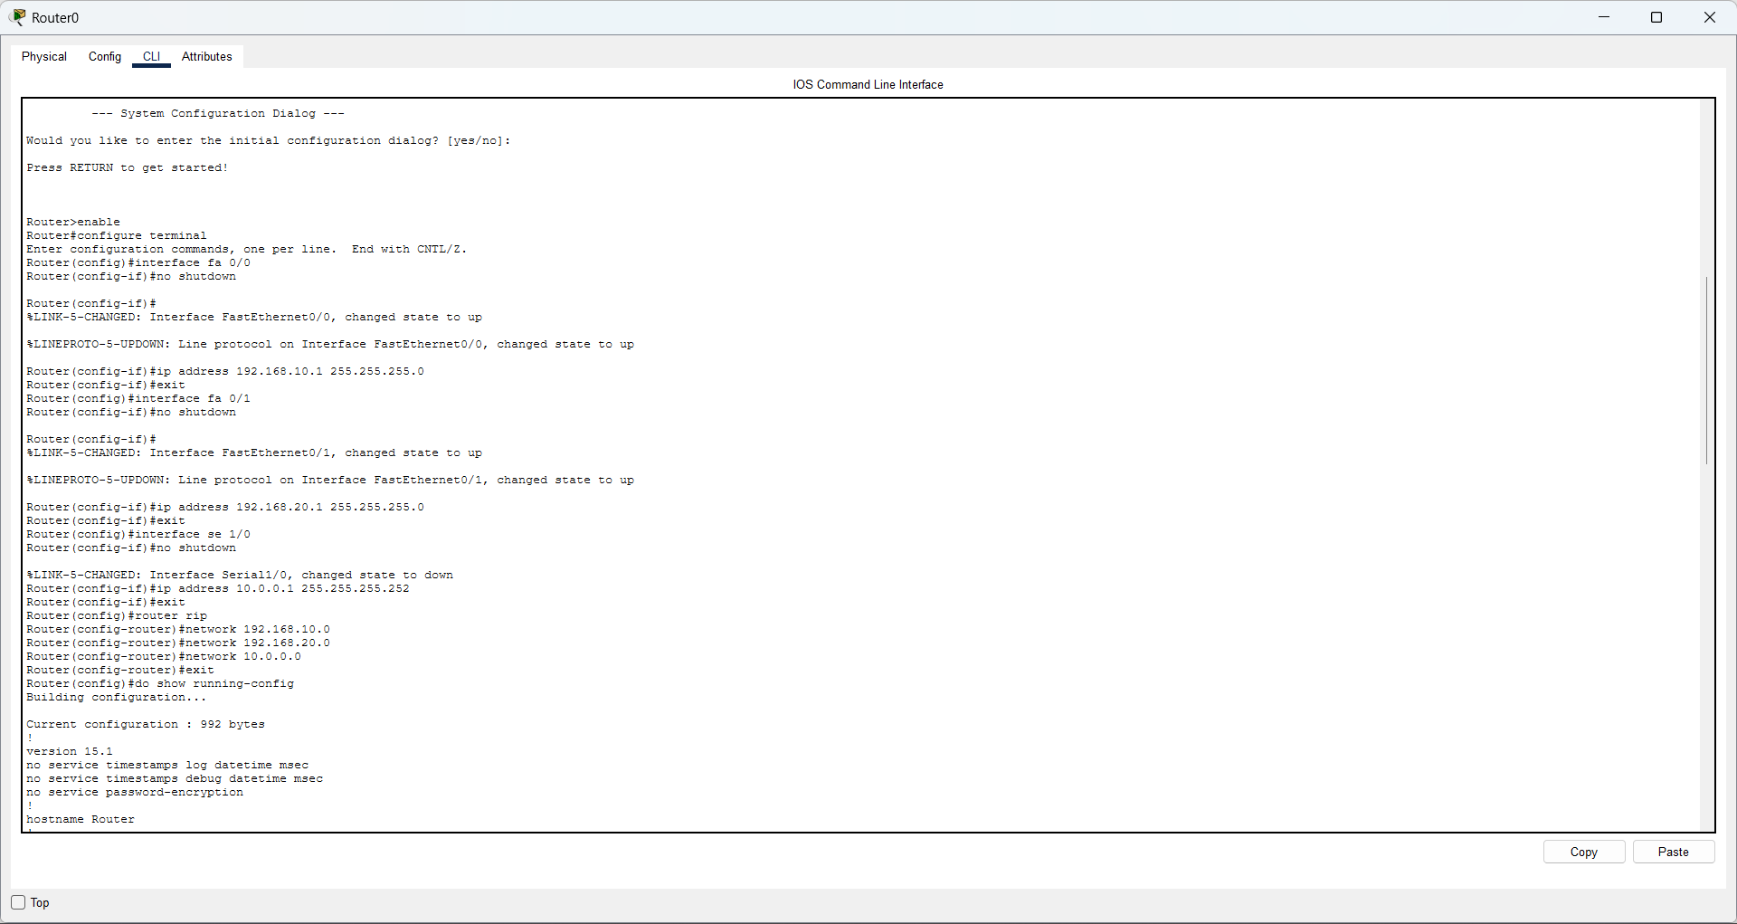
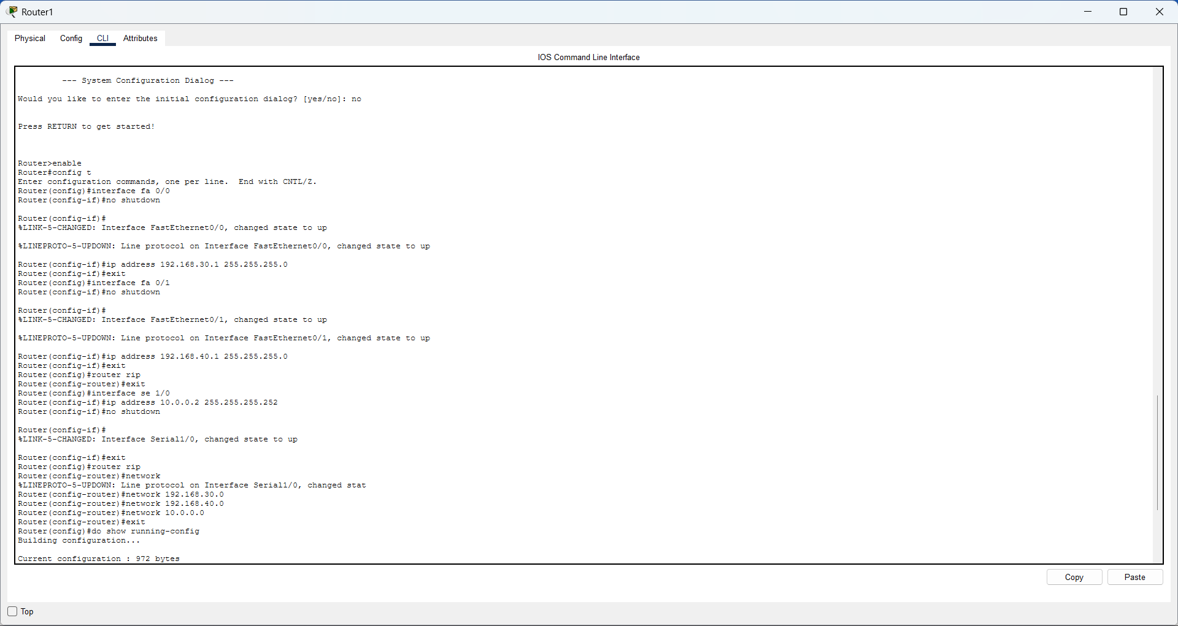
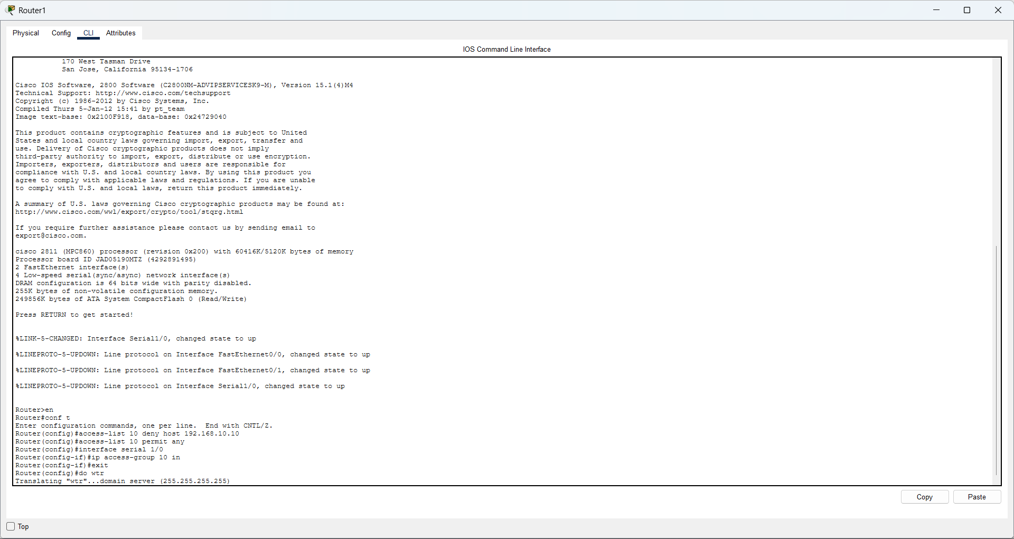
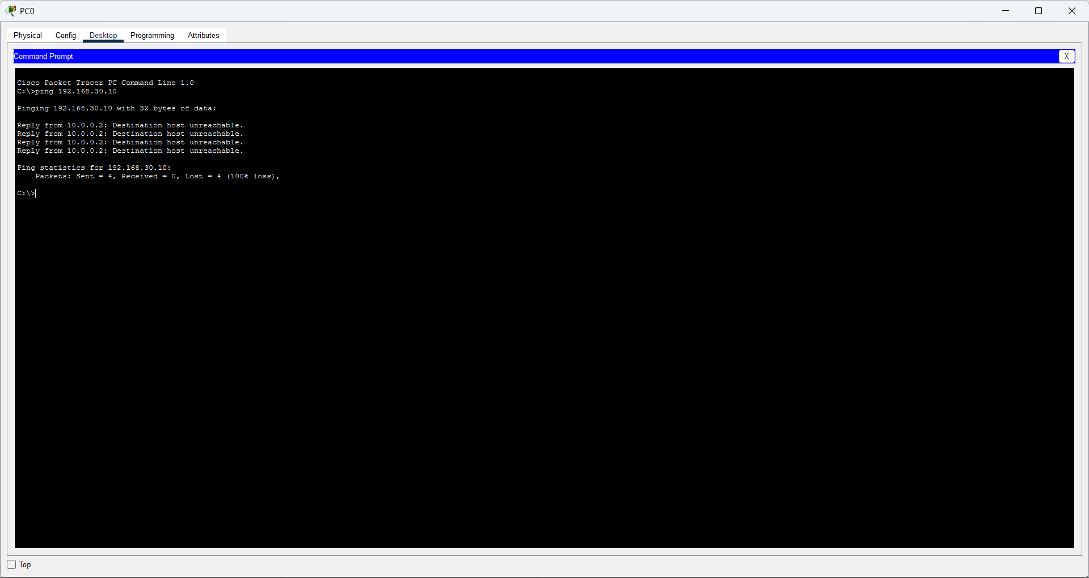
2. Extended ACL - Block One Network
Question: Configure an Extended ACL to block one entire network from accessing another network.
Commands
! Configure on Router0
access-list 110 deny ip 192.168.10.0 0.0.0.255 192.168.30.0 0.0.0.255
access-list 110 permit ip any any
interface fa0/0
ip access-group 110 in
exit
end
write
Check / Test
show access-lists 110
show ip interface fa0/0
! From a PC in 192.168.10.0/24:
ping 192.168.30.10
! Other destination test:
ping 192.168.40.10

Screenshot
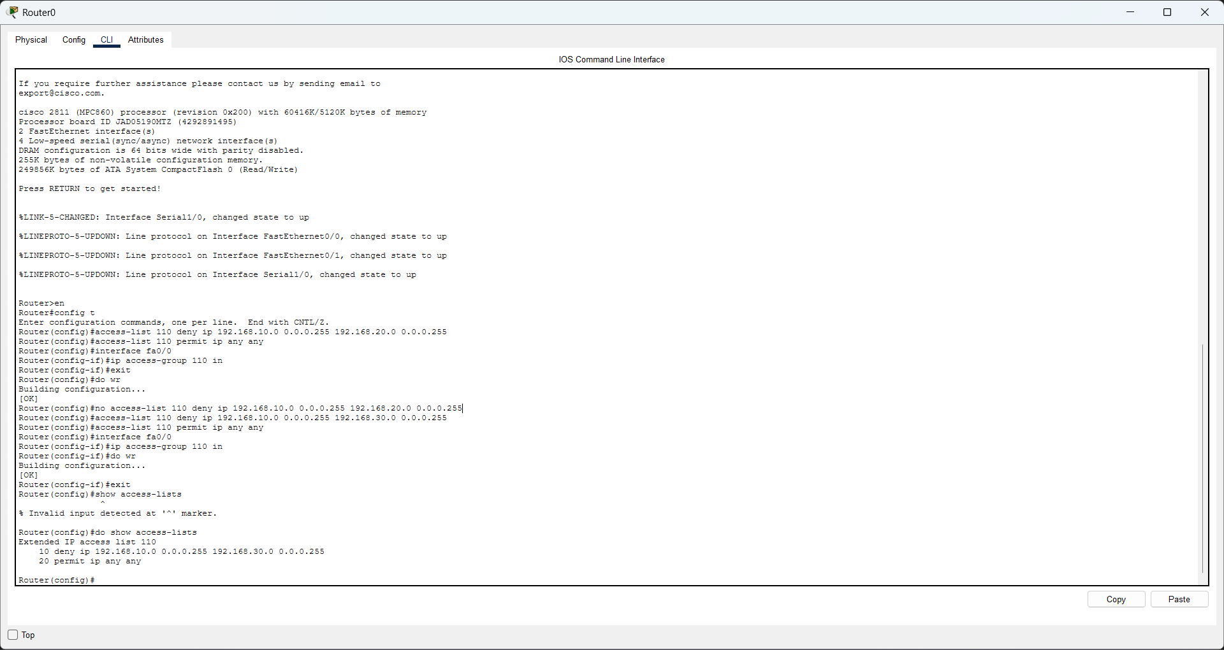
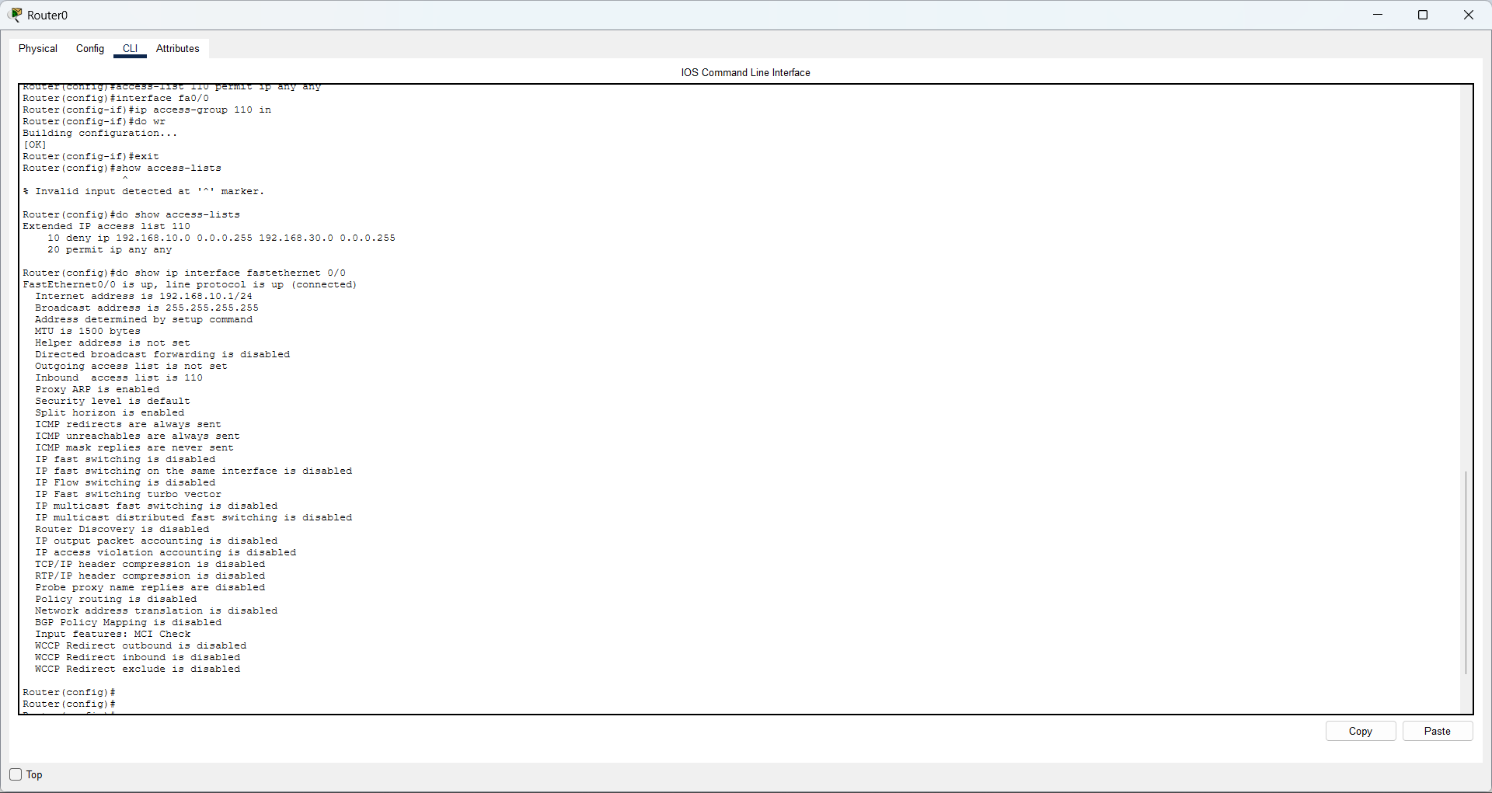
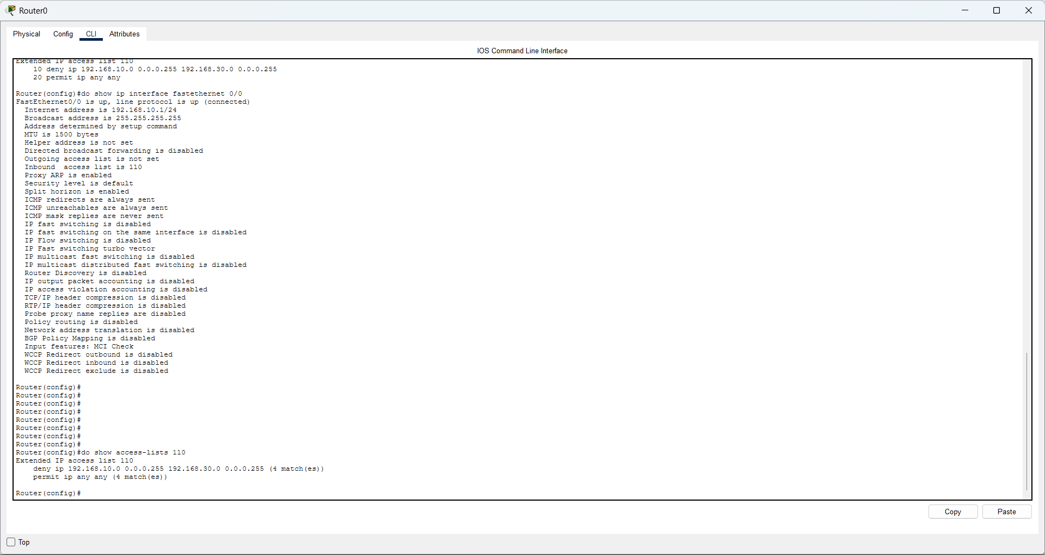
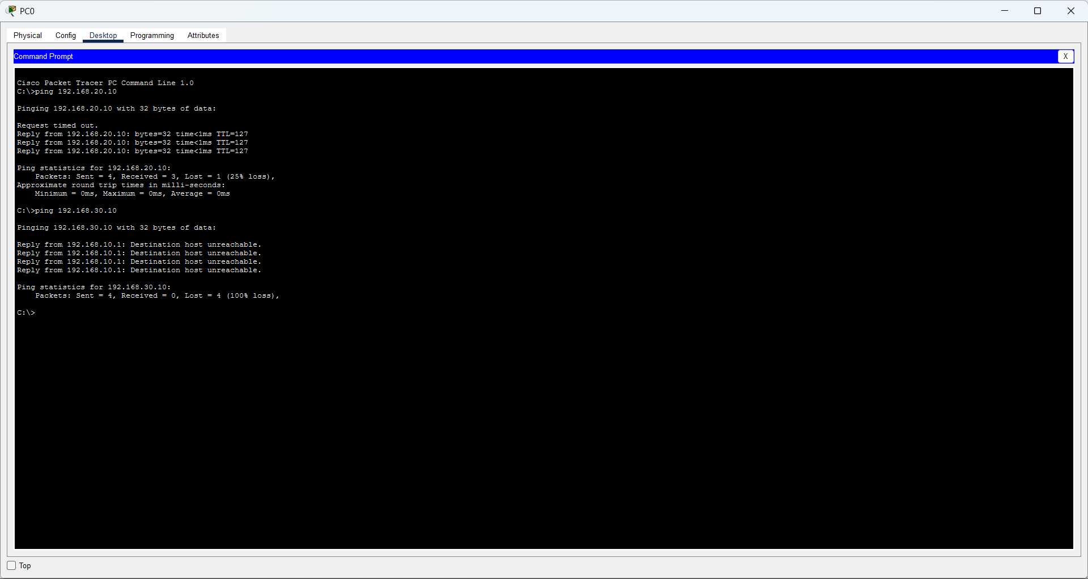
3. Extended ACL - Block Telnet and HTTP
Question: Configure an ACL to block services Telnet and HTTP between two networks.
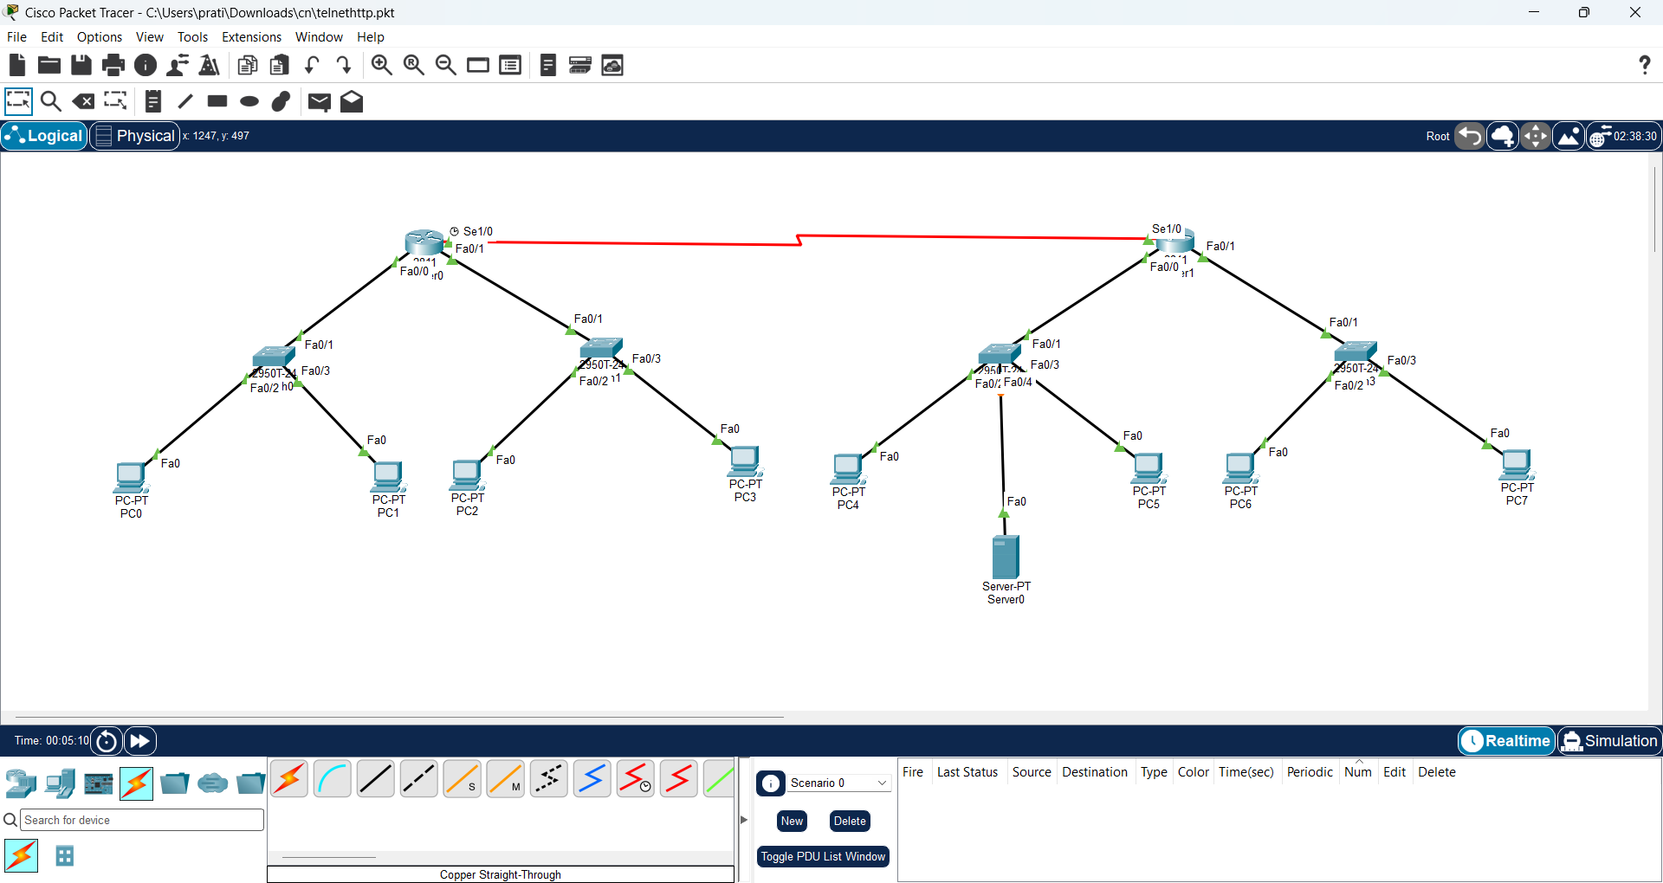
Commands
! Configure on Router0
access-list 120 deny tcp 192.168.10.0 0.0.0.255 192.168.30.0 0.0.0.255 eq 23
access-list 120 deny tcp 192.168.10.0 0.0.0.255 192.168.30.0 0.0.0.255 eq 80
access-list 120 permit ip any any
interface fa0/0
ip access-group 120 in
exit
end
write
Check / Test
show access-lists 120
show ip interface fa0/0
! Telnet test:
telnet 192.168.30.10
! HTTP: open the destination Server web page
! Other traffic should work:
ping 192.168.30.10

Screenshot
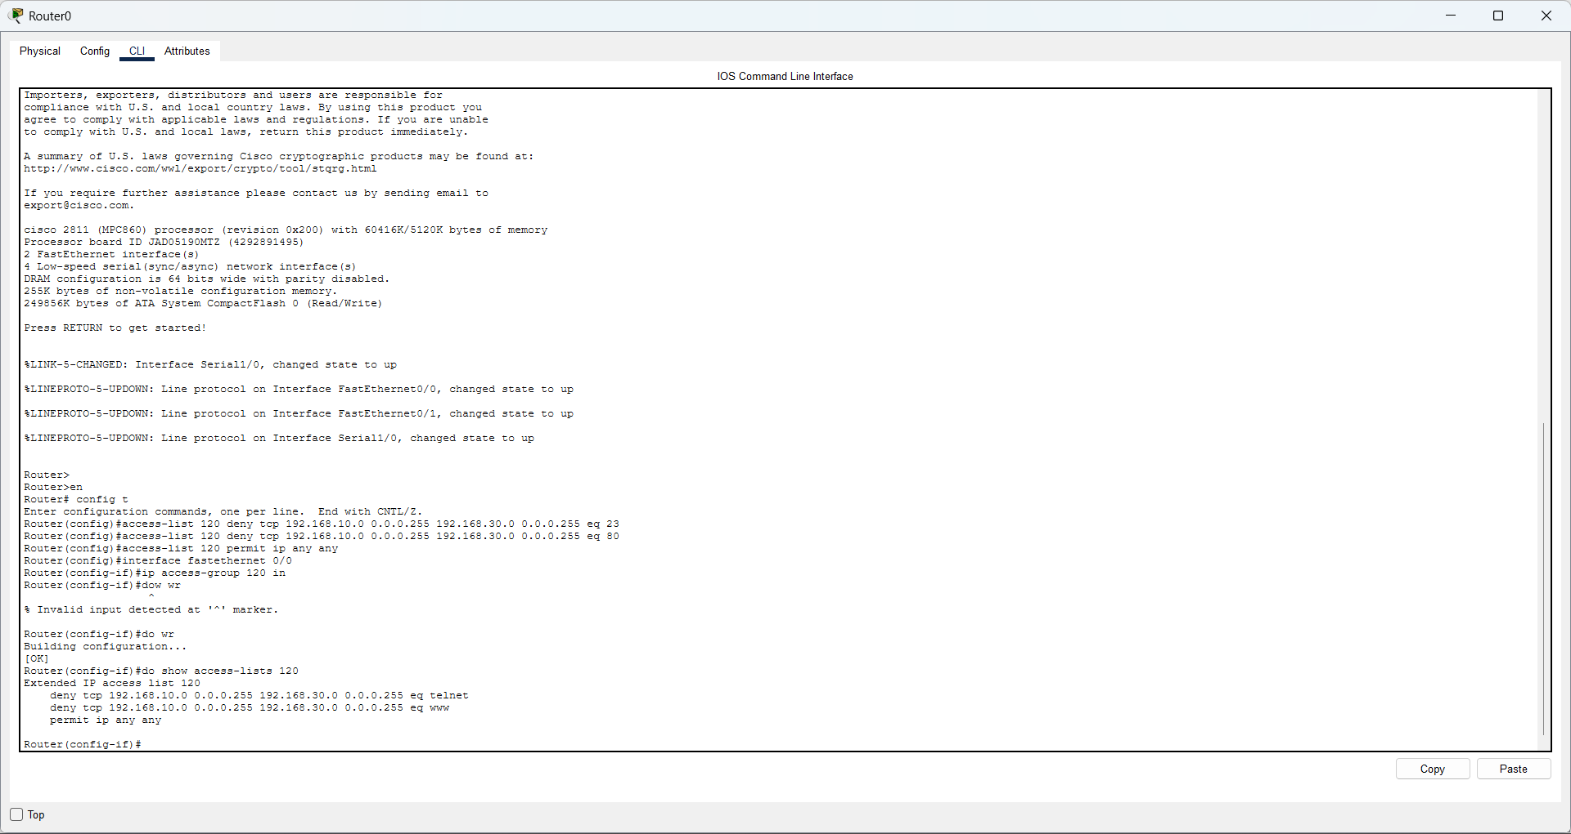
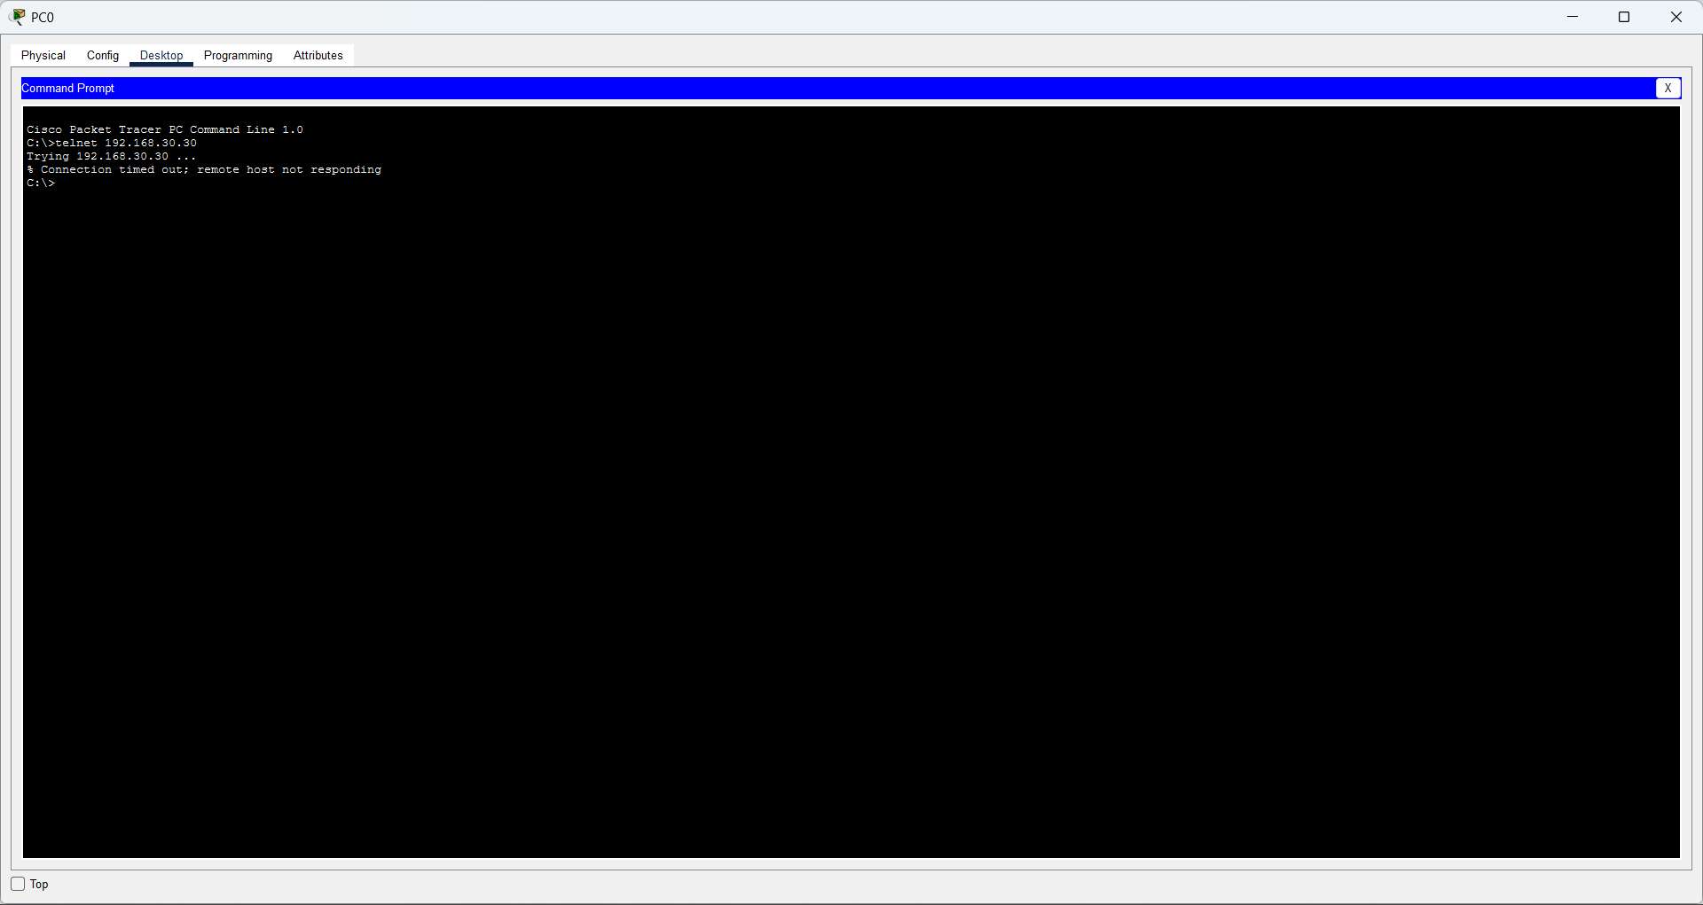
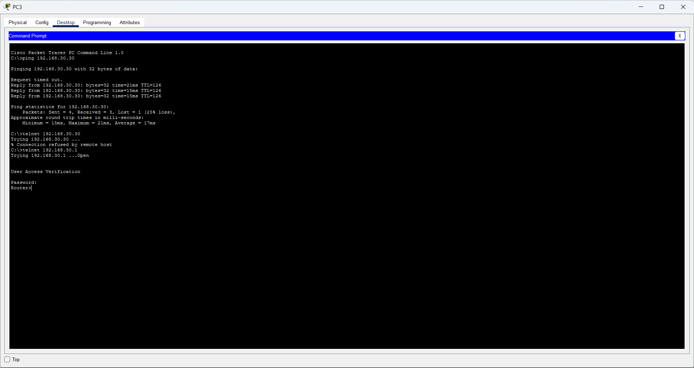
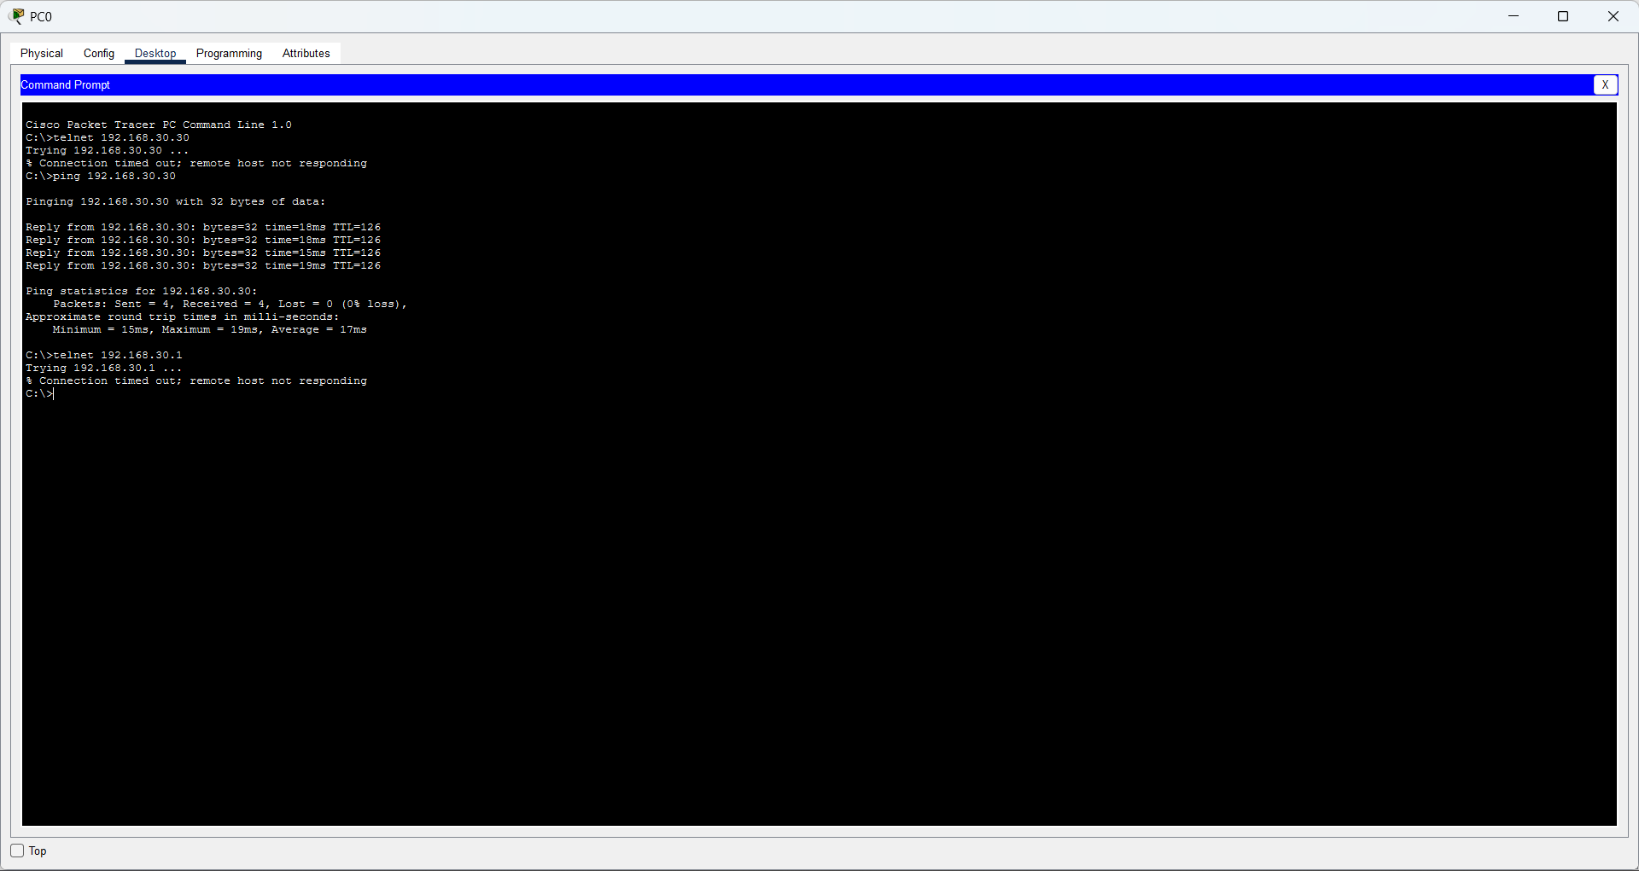
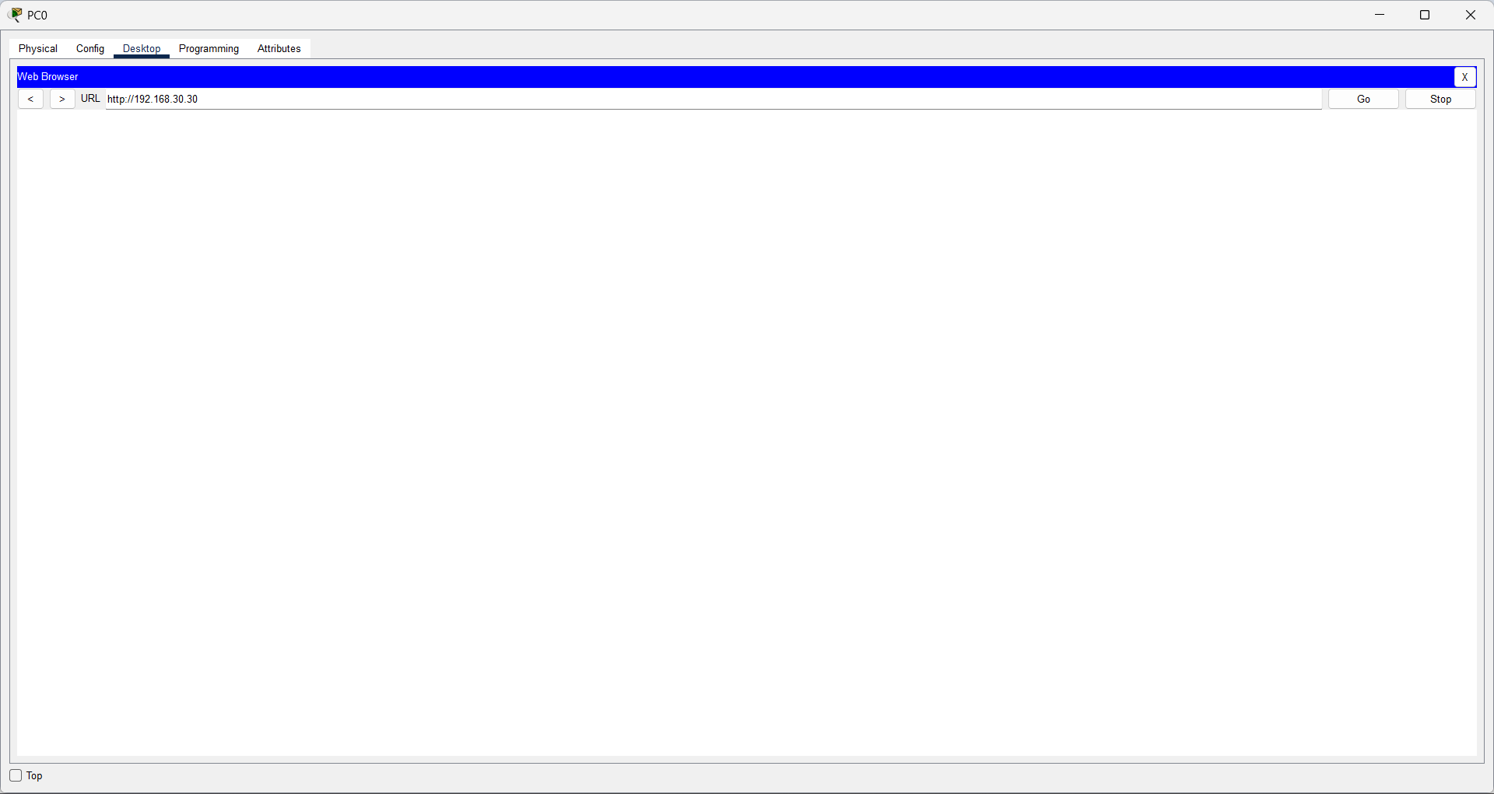
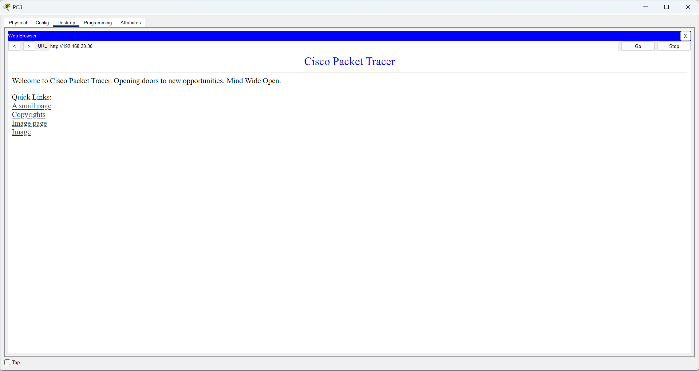

1. Static NAT
Question: Configure Static NAT on two routers so that an internal private IP address is translated to a fixed public IP address.
Commands
! Router0
interface fa0/0
ip nat inside
exit
interface fa0/1
ip nat inside
exit
interface se1/0
ip nat outside
exit
ip nat inside source static 192.168.10.10 100.0.0.10
ip route 200.0.0.0 255.255.255.0 10.0.0.2
! Router1
interface fa0/0
ip nat inside
exit
interface fa0/1
ip nat inside
exit
interface se1/0
ip nat outside
exit
ip nat inside source static 192.168.30.10 200.0.0.10
ip route 100.0.0.0 255.255.255.0 10.0.0.1
end
write
Check / Test
show ip nat translations
show ip nat statistics
! Confirm mappings:
! R0: 192.168.10.10 <-> 100.0.0.10
! R1: 192.168.30.10 <-> 200.0.0.10

Screenshot
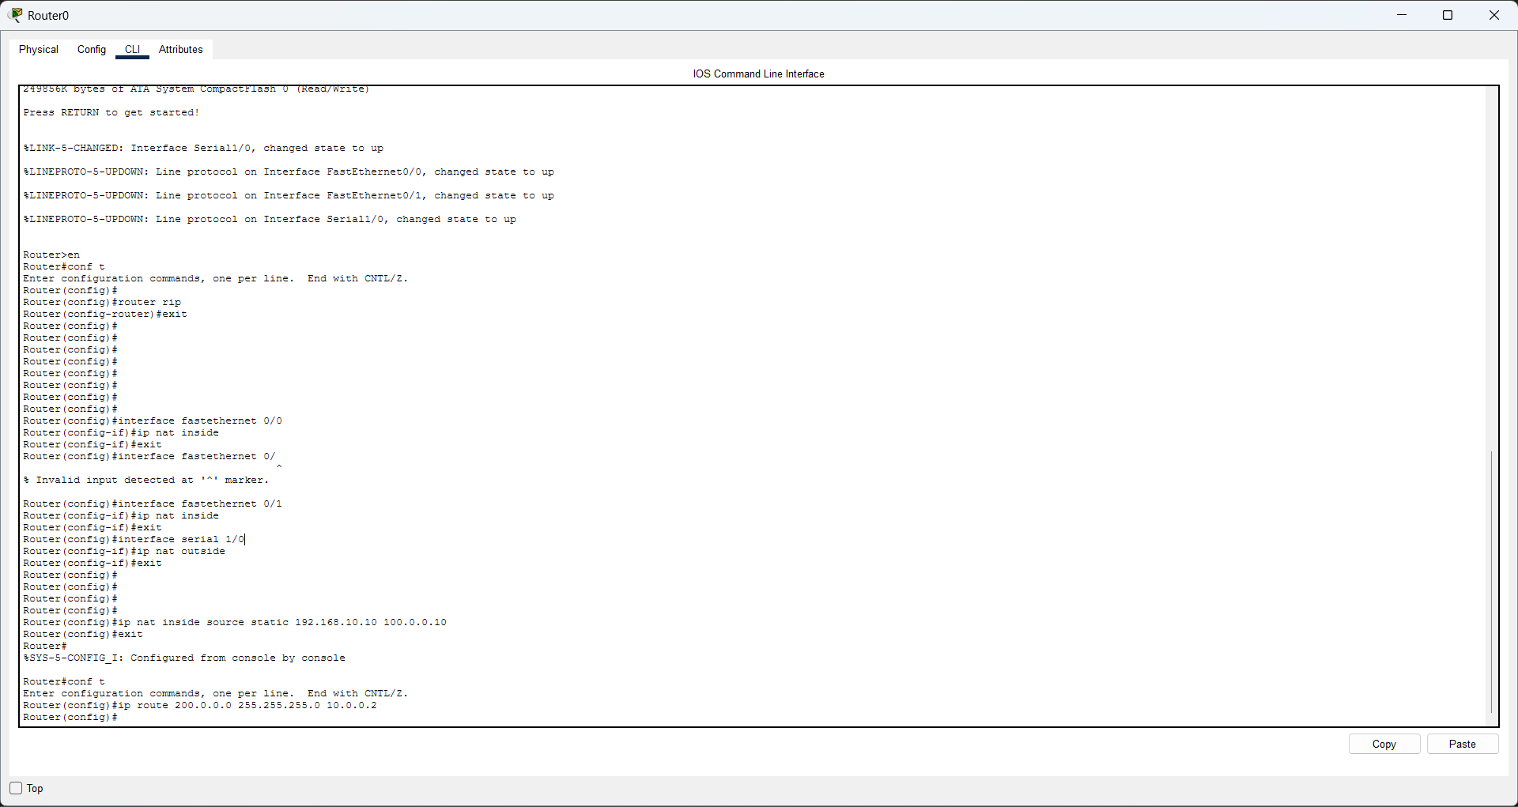
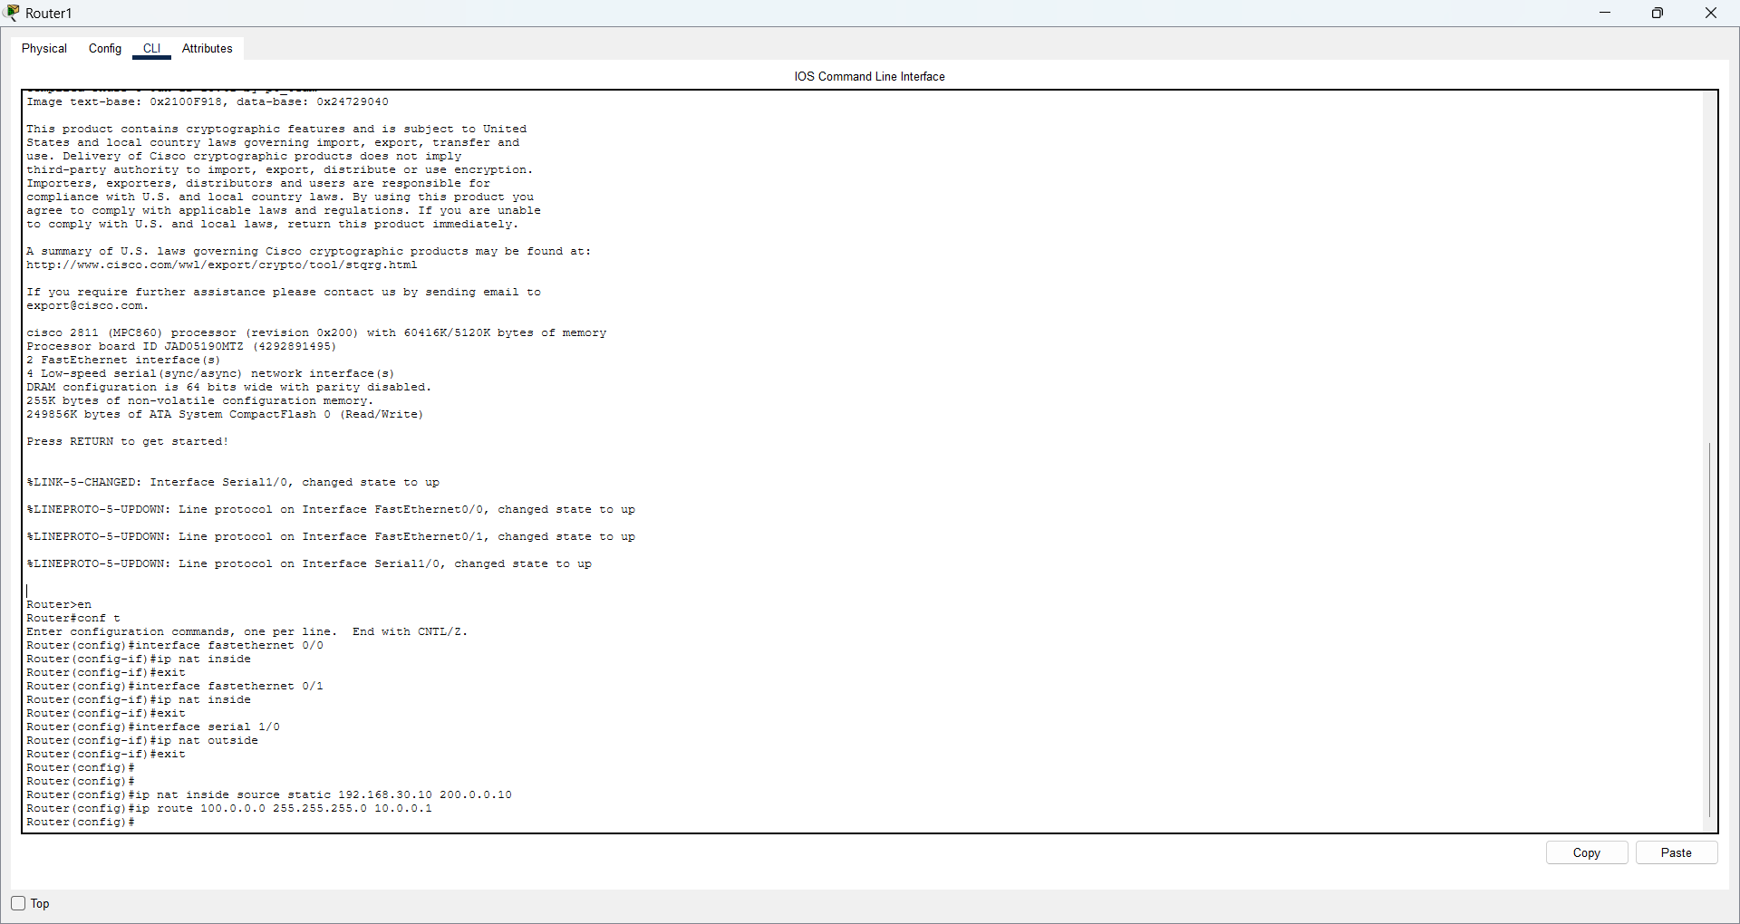
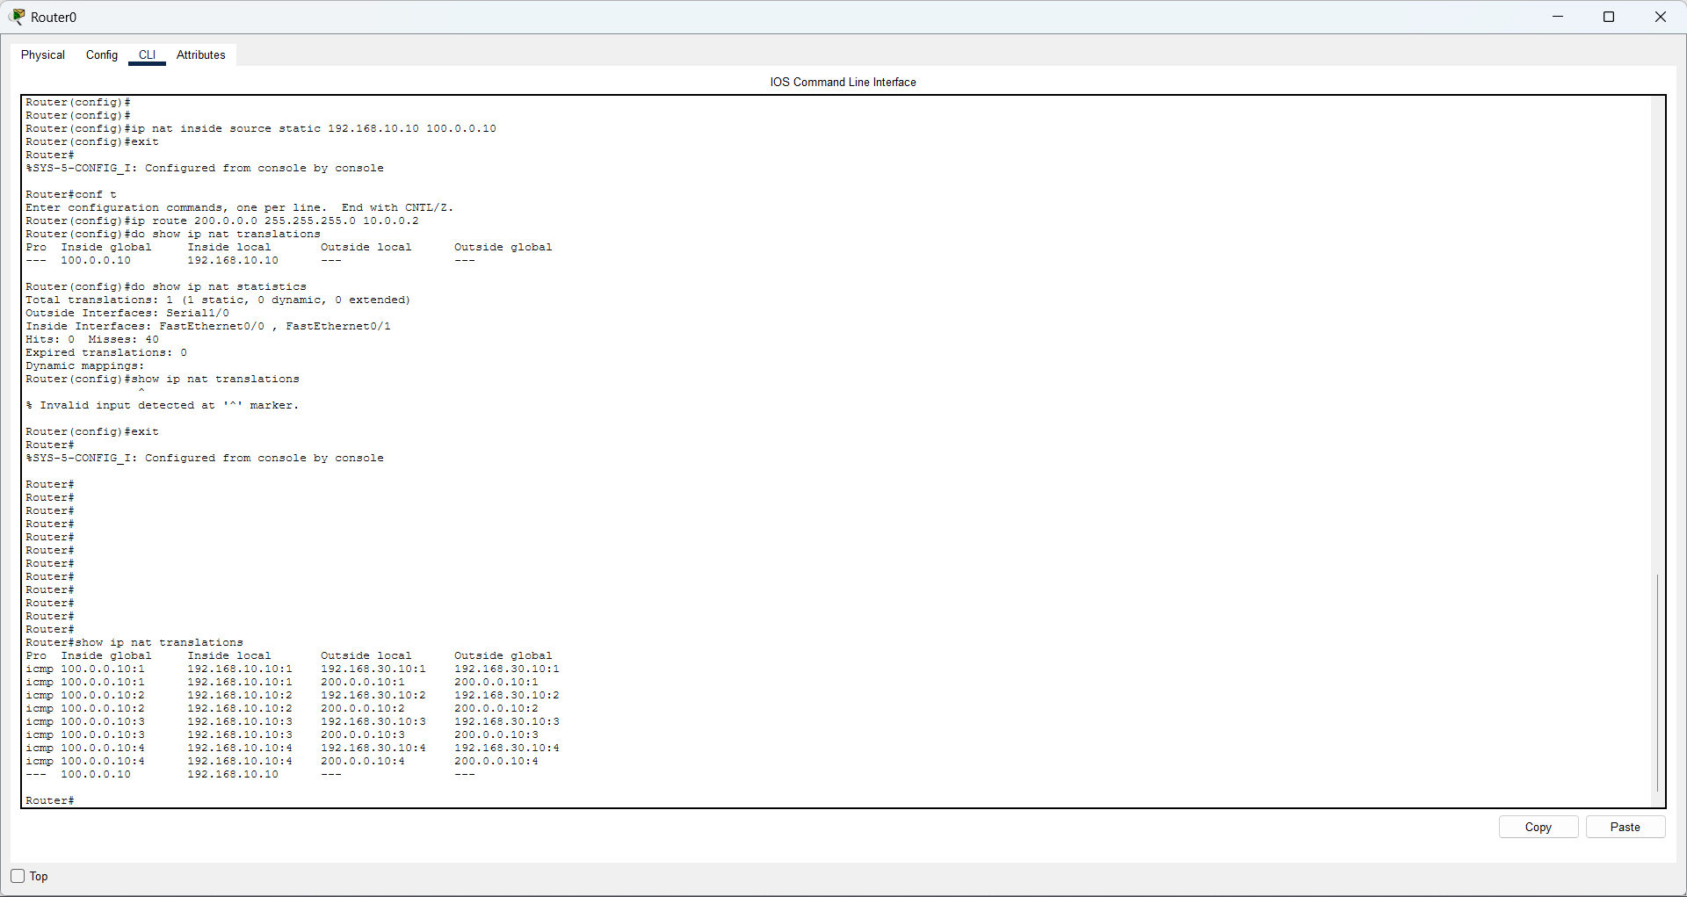

2. Dynamic NAT
Question: Configure Dynamic NAT on two routers so that a pool of public IP addresses is used to translate multiple private IP addresses.
Commands
! Router0
interface fa0/0
ip nat inside
exit
interface fa0/1
ip nat inside
exit
interface se1/0
ip nat outside
exit
access-list 1 permit 192.168.10.0 0.0.0.255
access-list 1 permit 192.168.20.0 0.0.0.255
ip nat pool R1POOL 100.0.0.10 100.0.0.20 netmask 255.255.255.0
ip nat inside source list 1 pool R1POOL
! Router1
interface fa0/0
ip nat inside
exit
interface fa0/1
ip nat inside
exit
interface se1/0
ip nat outside
exit
access-list 2 permit 192.168.30.0 0.0.0.255
access-list 2 permit 192.168.40.0 0.0.0.255
ip nat pool R2POOL 200.0.0.10 200.0.0.20 netmask 255.255.255.0
ip nat inside source list 2 pool R2POOL
end
write
Check / Test
show access-lists 1
show access-lists 2
show ip nat translations
show ip nat statistics
! Generate traffic from several inside PCs first.

Screenshot
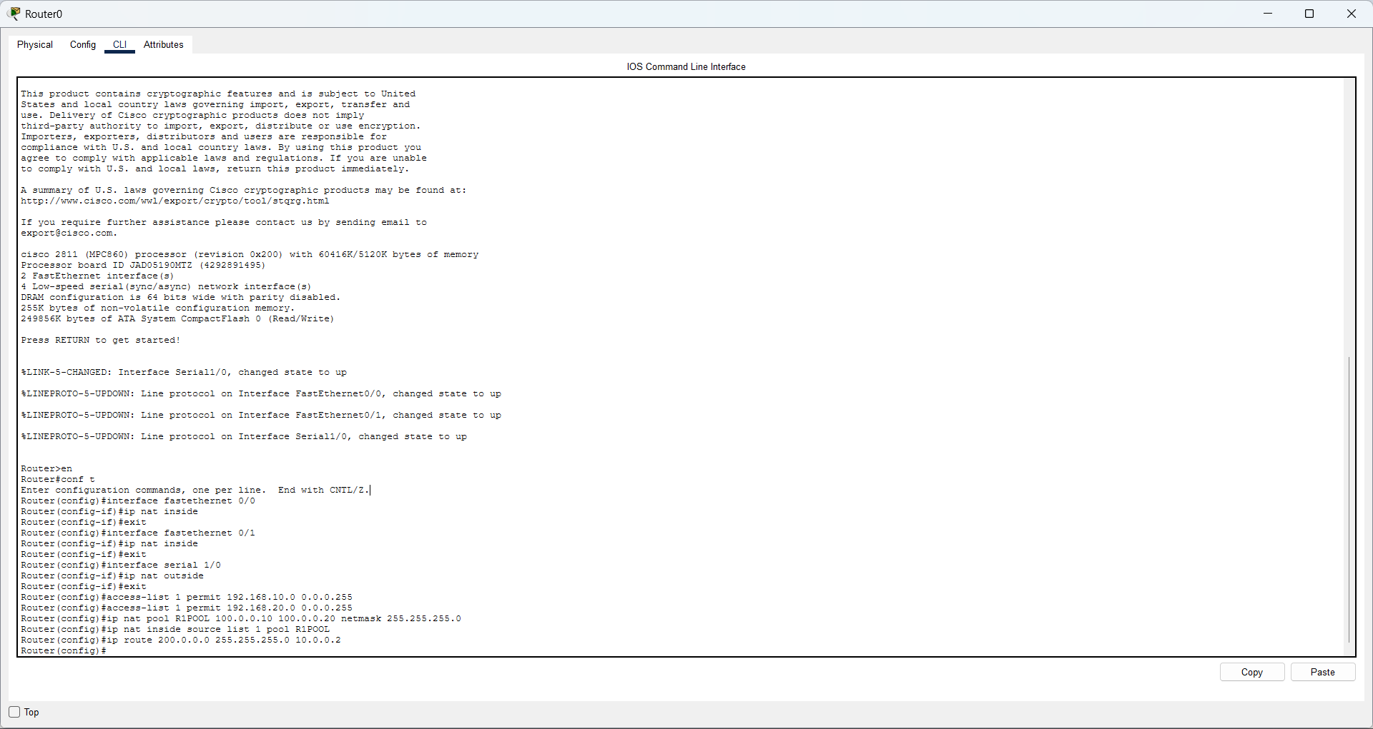
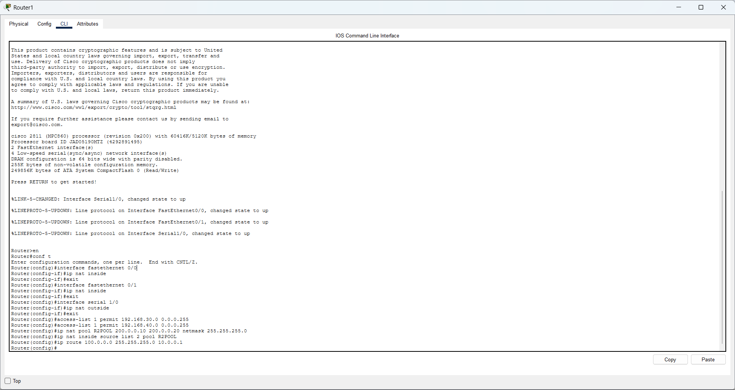
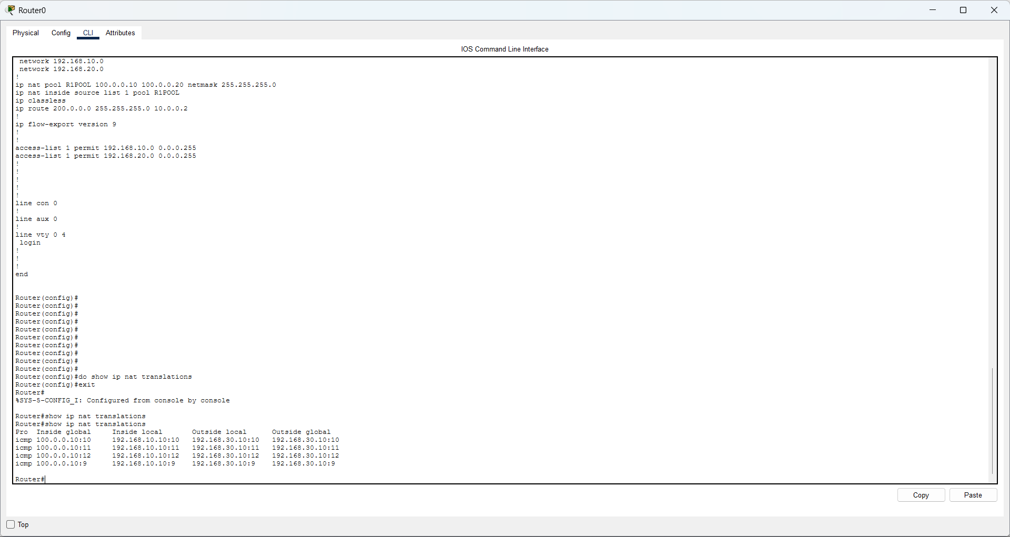

3. PAT (NAT Overload)
Question: Configure PAT (Port Address Translation) on two routers so that many private IP addresses share a single public IP address using different ports.
Commands
! Router0
interface fa0/0
ip nat inside
exit
interface fa0/1
ip nat inside
exit
interface se1/0
ip nat outside
exit
access-list 11 permit 192.168.10.0 0.0.0.255
access-list 11 permit 192.168.20.0 0.0.0.255
ip nat inside source list 11 interface se1/0 overload
! Router1
interface fa0/0
ip nat inside
exit
interface fa0/1
ip nat inside
exit
interface se1/0
ip nat outside
exit
access-list 12 permit 192.168.30.0 0.0.0.255
access-list 12 permit 192.168.40.0 0.0.0.255
ip nat inside source list 12 interface se1/0 overload
end
write
Check / Test
show access-lists 11
show access-lists 12
show ip nat translations
show ip nat statistics
! Generate simultaneous traffic from several PCs.

Screenshot
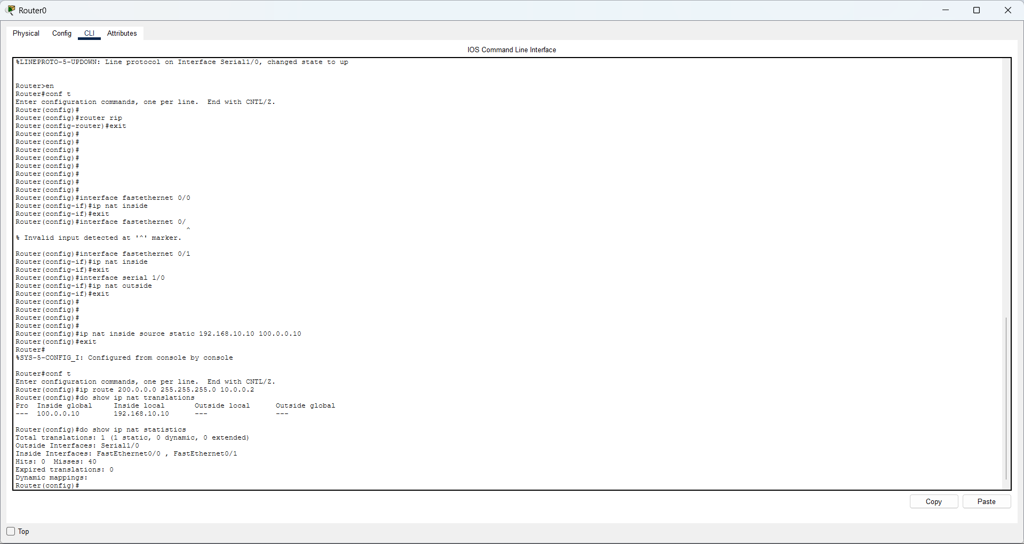
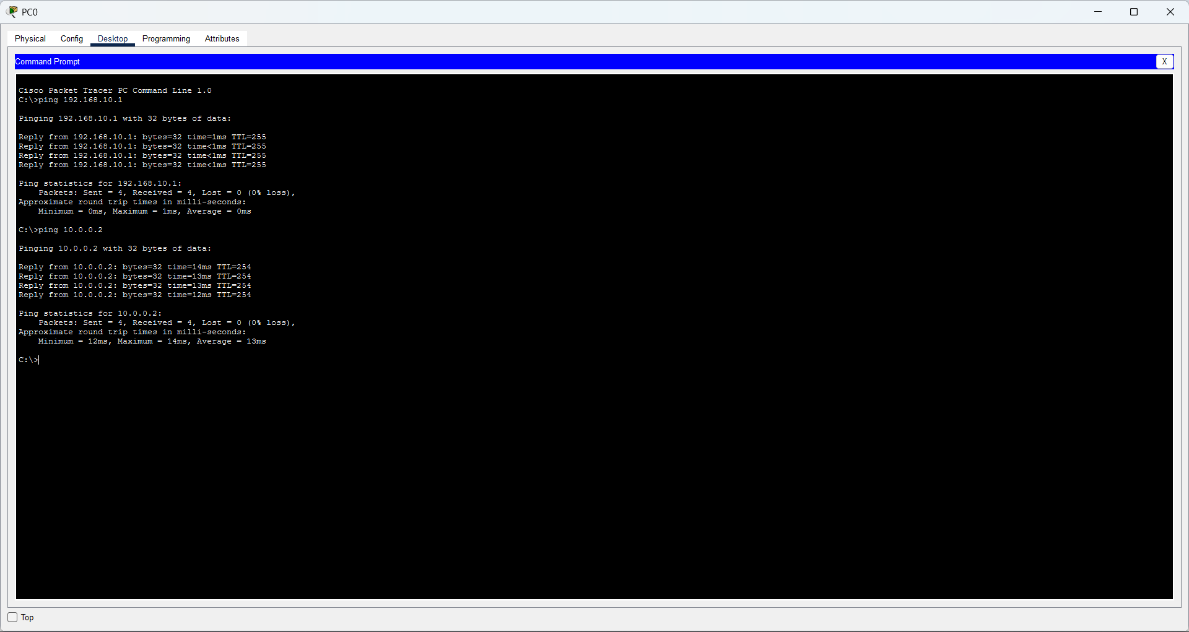
1. RIPng for IPv6
Question: Configure RIP for IPv6 on two routers so that both routers exchange IPv6 routing information.
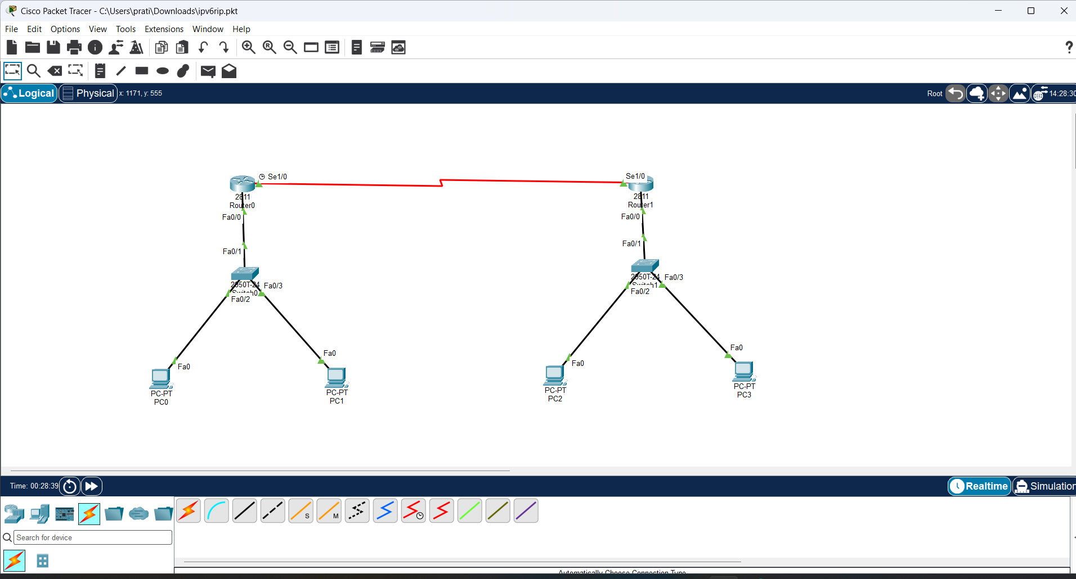
Commands
! Router0
ipv6 unicast-routing
interface fa0/0
ipv6 address 2001:DB8:1::1/64
no shutdown
exit
interface se1/0
ipv6 address 2001:DB8:12::1/64
clock rate 64000
no shutdown
exit
ipv6 router rip RIPNG
exit
interface fa0/0
ipv6 rip RIPNG enable
exit
interface se1/0
ipv6 rip RIPNG enable
exit
! Router1
ipv6 unicast-routing
interface fa0/0
ipv6 address 2001:DB8:2::1/64
no shutdown
exit
interface se1/0
ipv6 address 2001:DB8:12::2/64
no shutdown
exit
ipv6 router rip RIPNG
exit
interface fa0/0
ipv6 rip RIPNG enable
exit
interface se1/0
ipv6 rip RIPNG enable
exit
end
write
Check / Test
show ipv6 interface brief
show ipv6 route
show ipv6 protocols
! Router0 should learn 2001:DB8:2::/64 as R.
! Router1 should learn 2001:DB8:1::/64 as R.
! From PC0:
ping 2001:DB8:2::10

Screenshot
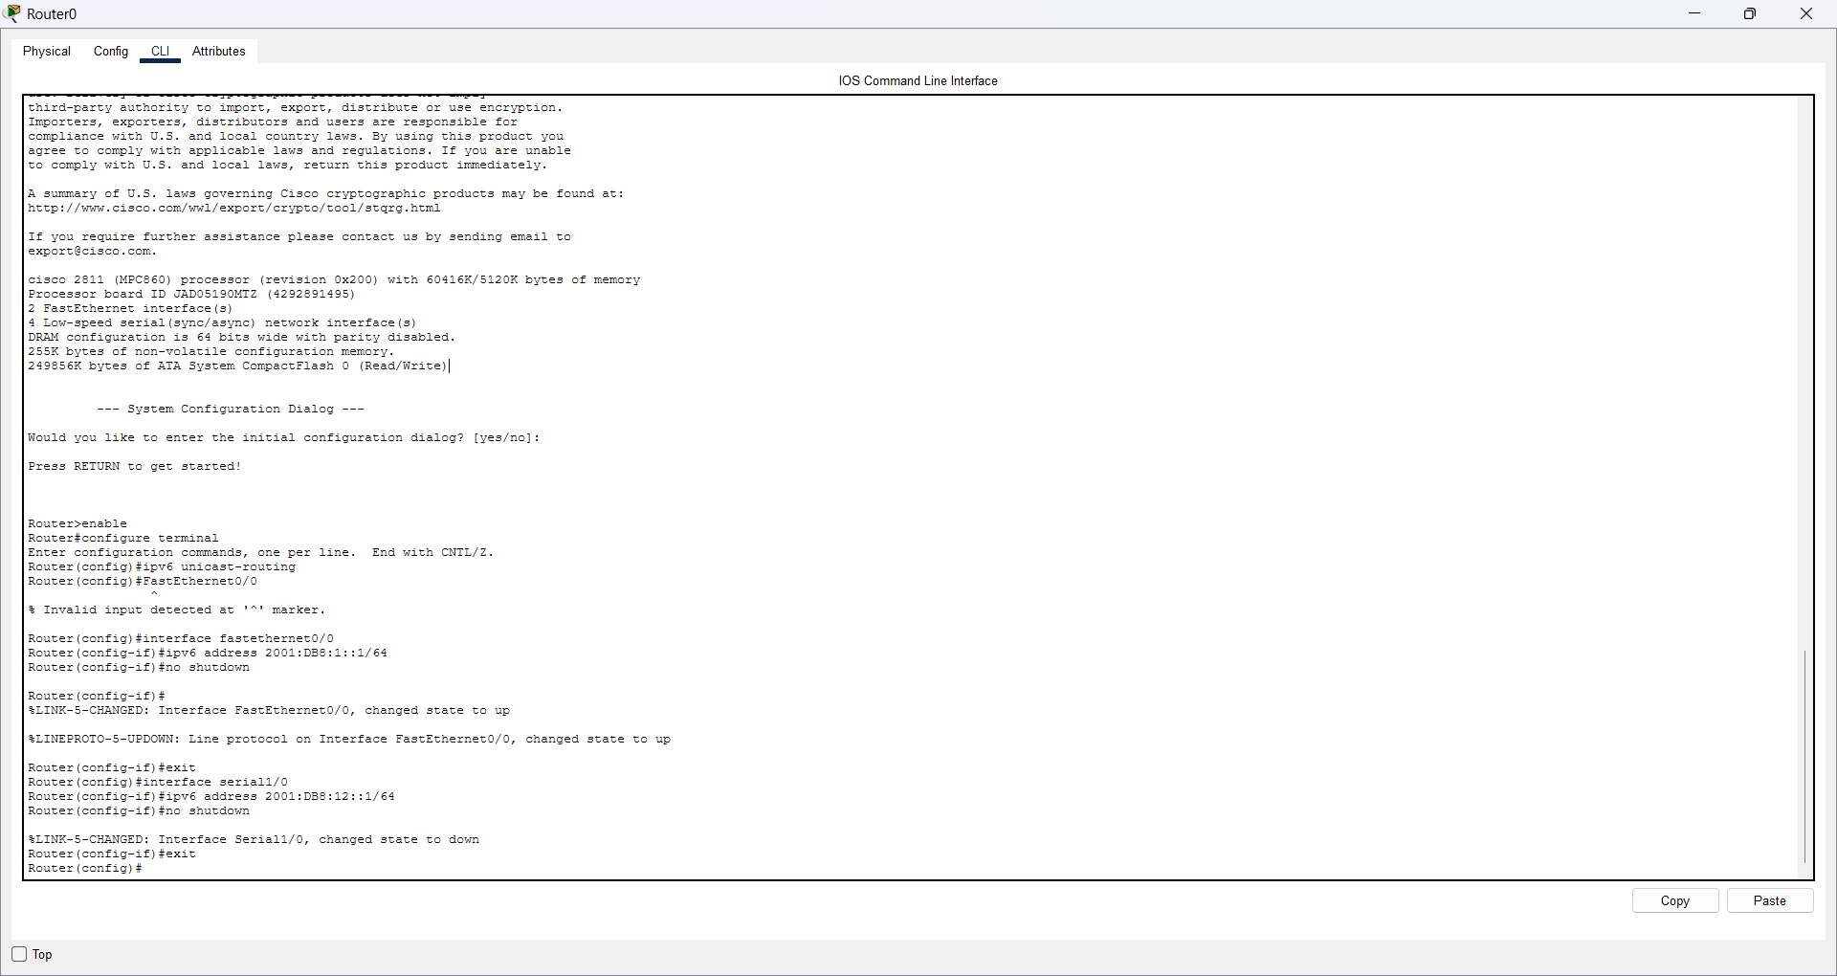
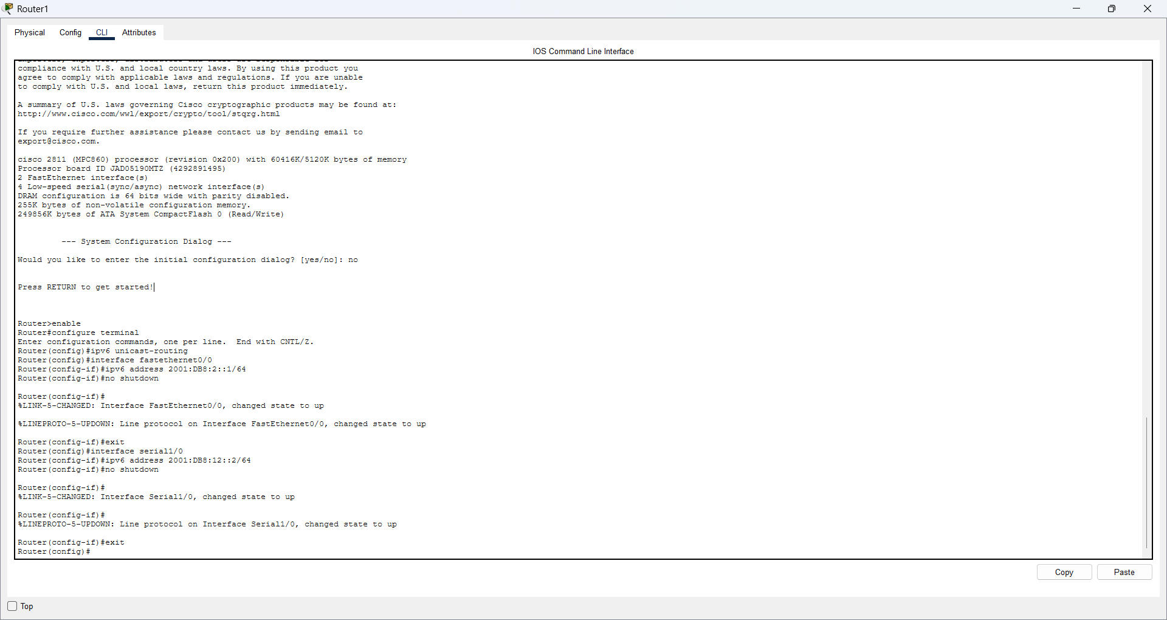
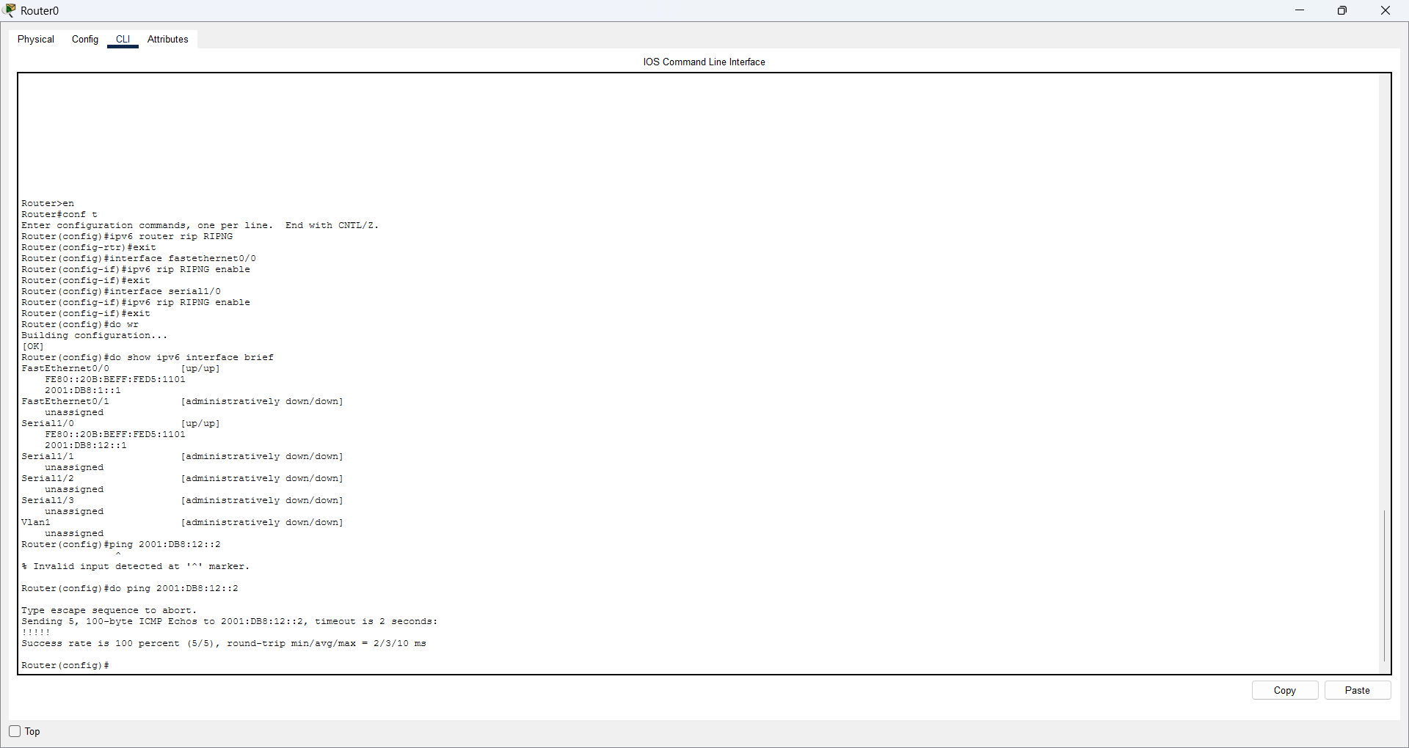
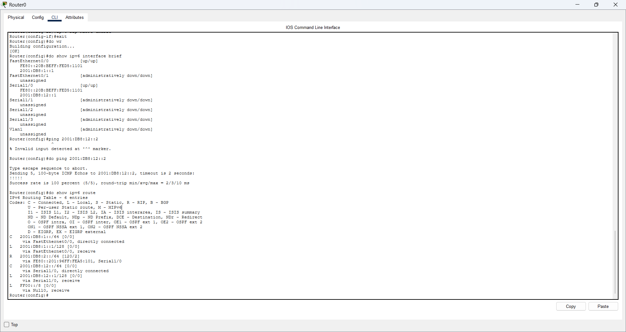
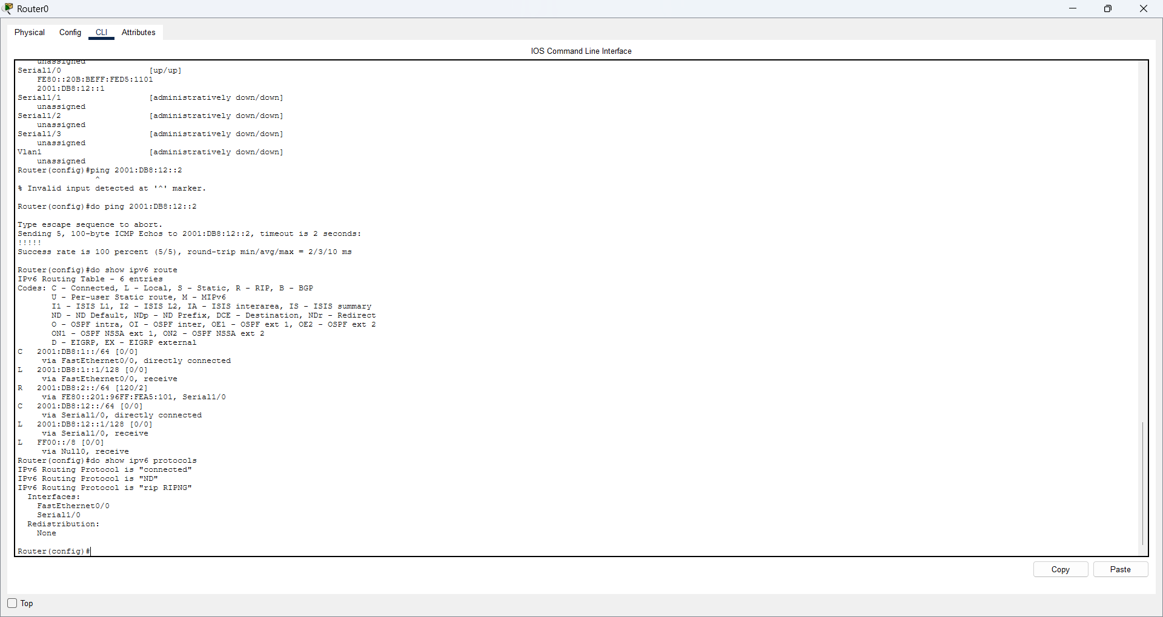
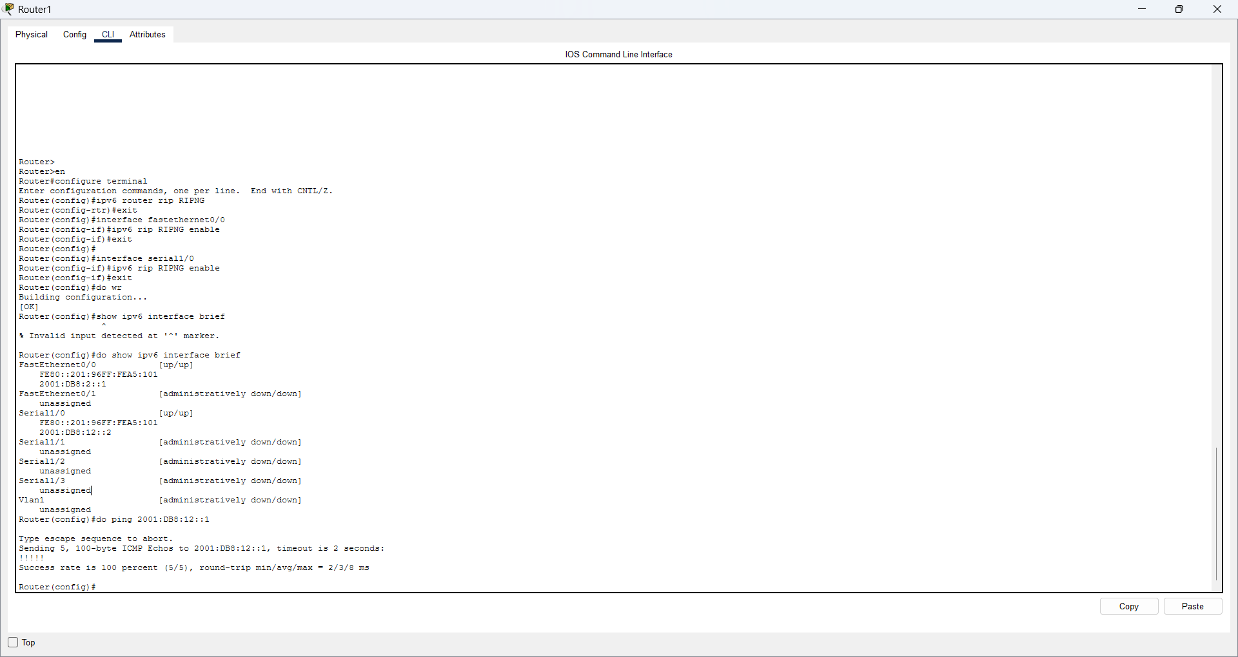
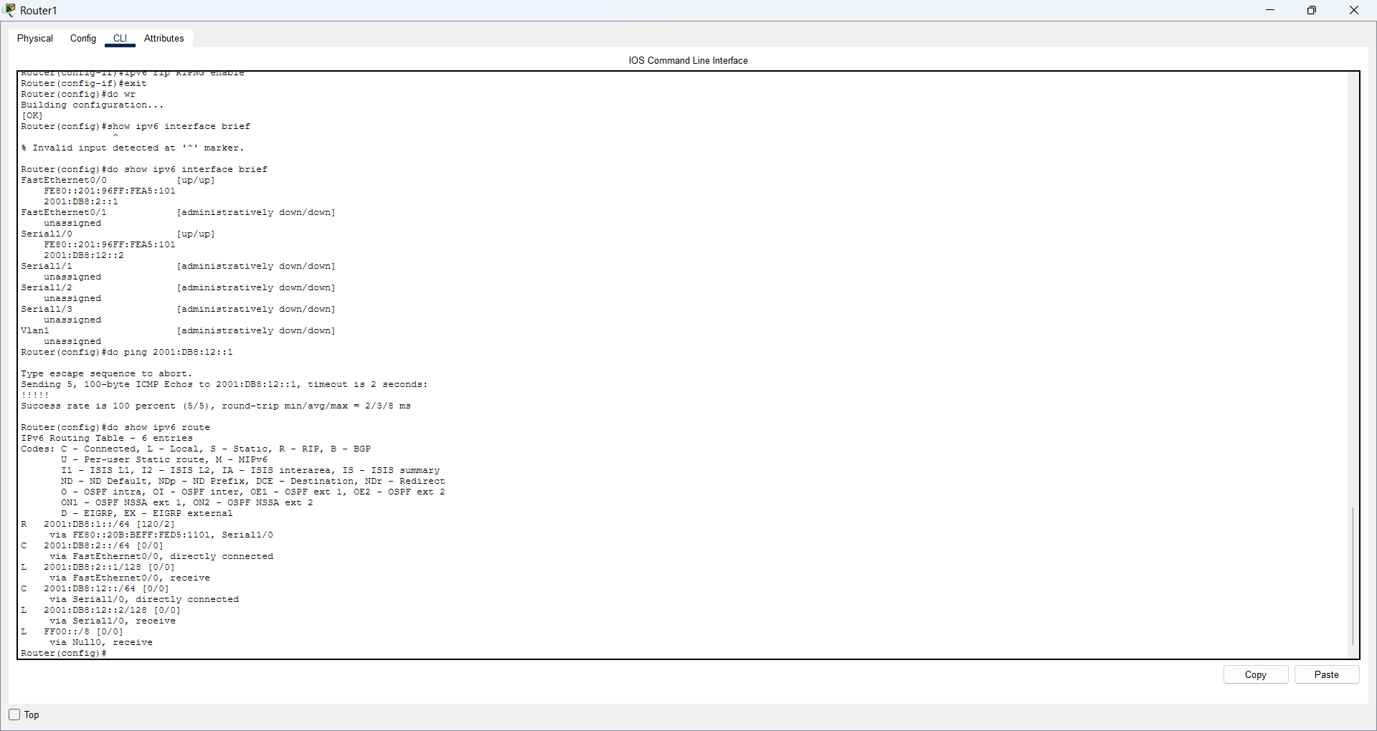
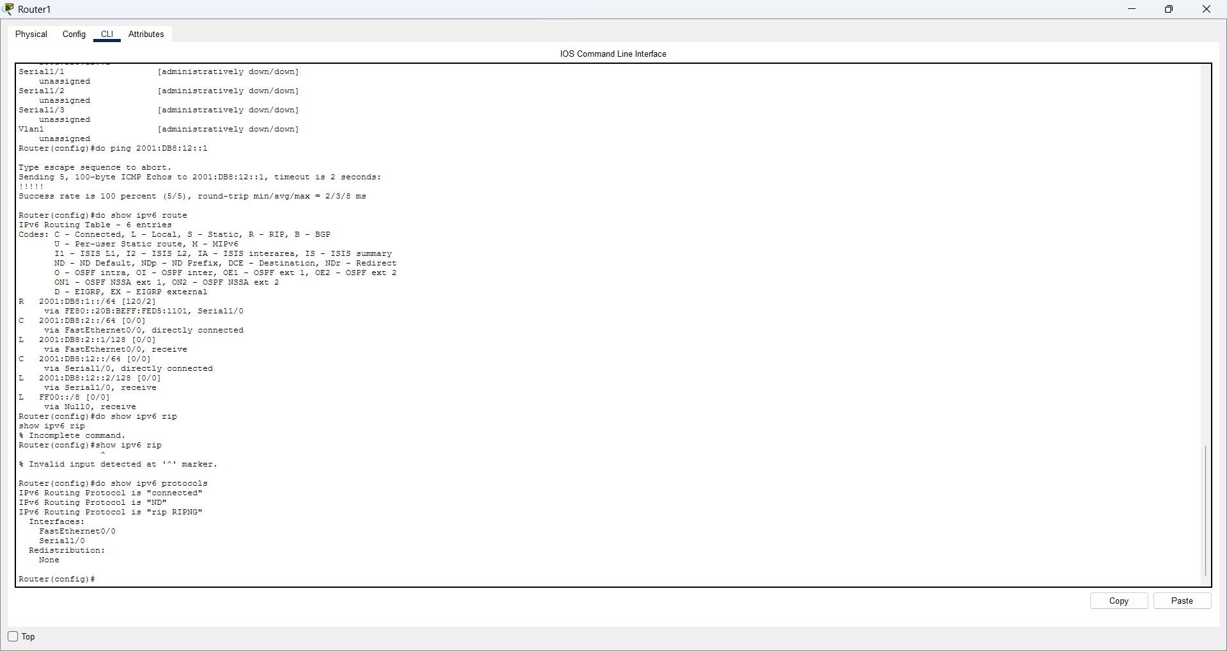
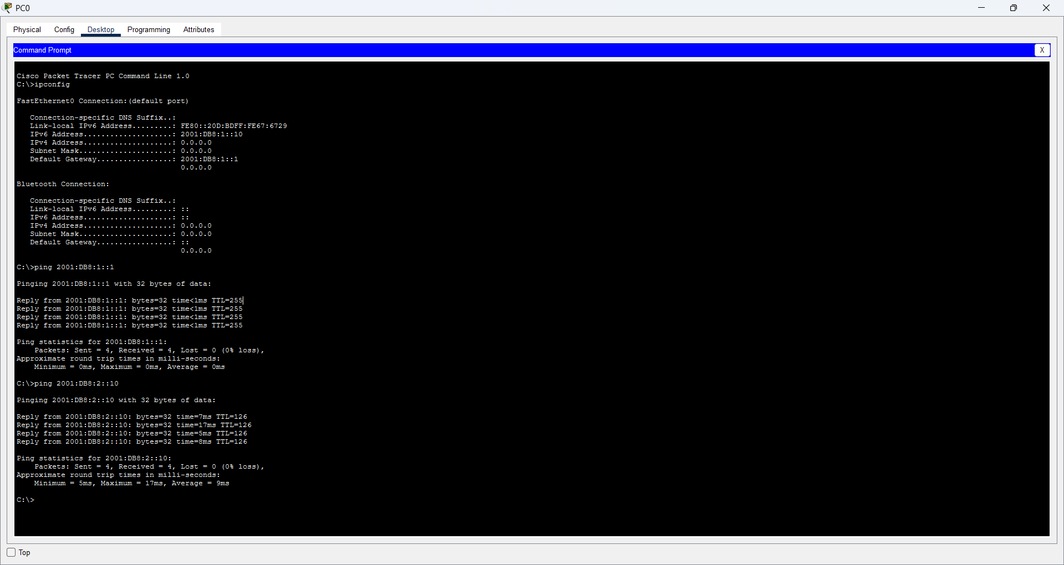

2. EIGRP Routing for IPv6
Question: Two routers are connected in a line; each router has two switches, and each switch has two PCs. Configure EIGRP Routing. Assign the same AS number to the routers. Check whether the PCs can communicate.
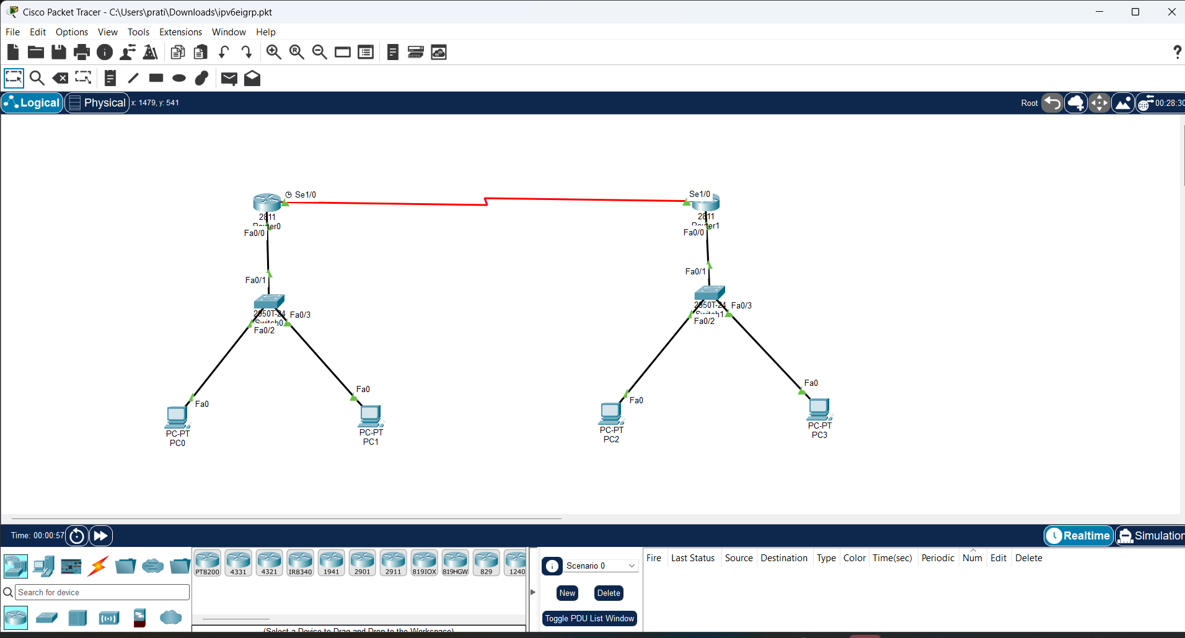
Commands
! Router0
ipv6 unicast-routing
interface fa0/0
ipv6 address 2001:DB8:1::1/64
ipv6 eigrp 100
no shutdown
exit
interface fa0/1
ipv6 address 2001:DB8:2::1/64
ipv6 eigrp 100
no shutdown
exit
interface se1/0
ipv6 address 2001:DB8:12::1/64
ipv6 eigrp 100
clock rate 64000
no shutdown
exit
ipv6 router eigrp 100
eigrp router-id 1.1.1.1
no shutdown
exit
! Router1
ipv6 unicast-routing
interface fa0/0
ipv6 address 2001:DB8:3::1/64
ipv6 eigrp 100
no shutdown
exit
interface fa0/1
ipv6 address 2001:DB8:4::1/64
ipv6 eigrp 100
no shutdown
exit
interface se1/0
ipv6 address 2001:DB8:12::2/64
ipv6 eigrp 100
no shutdown
exit
ipv6 router eigrp 100
eigrp router-id 2.2.2.2
no shutdown
exit
end
write
Check / Test
show ipv6 interface brief
show ipv6 eigrp neighbors
show ipv6 route
! Look for R0/R1 as EIGRP neighbors.
! Remote routes should be marked D.
! From PC0:
ping 2001:DB8:3::10
ping 2001:DB8:4::10

Screenshot
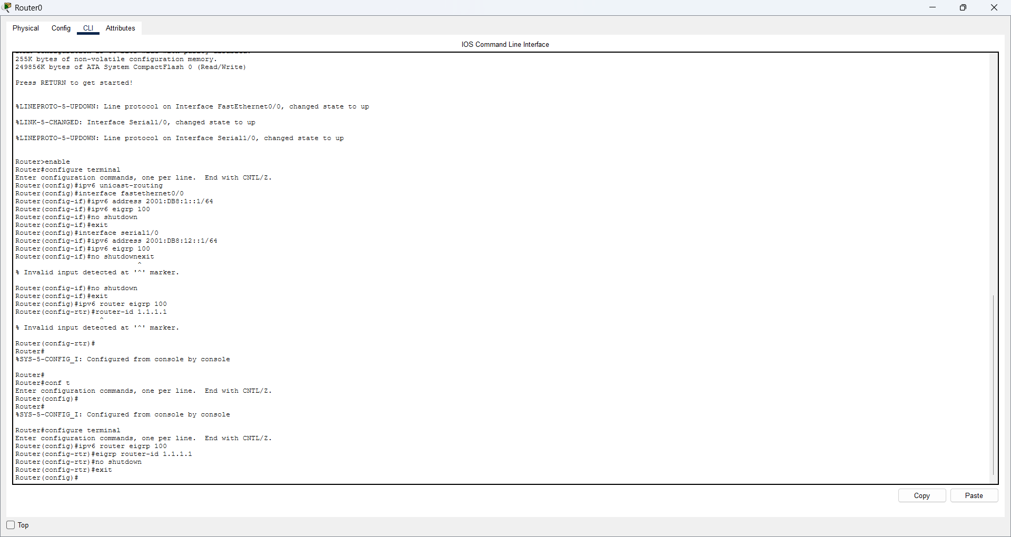
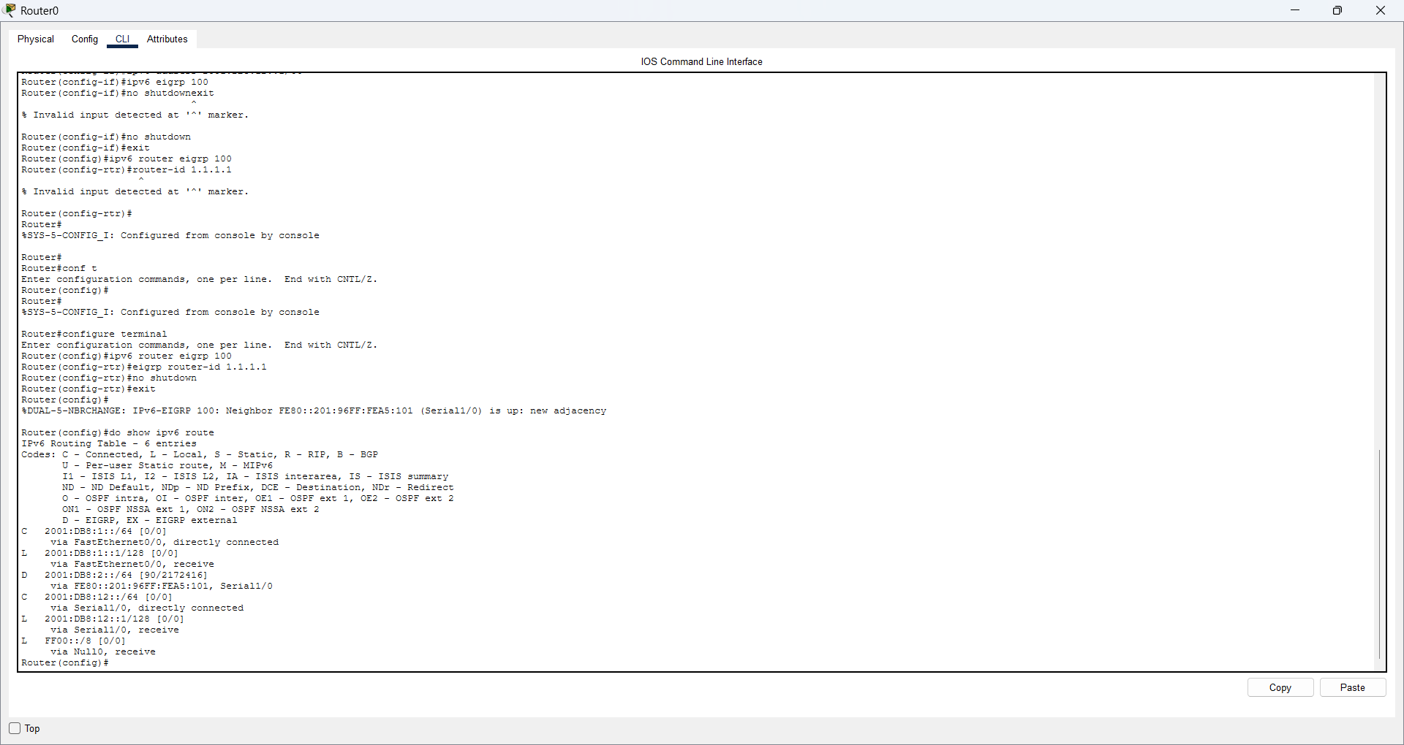
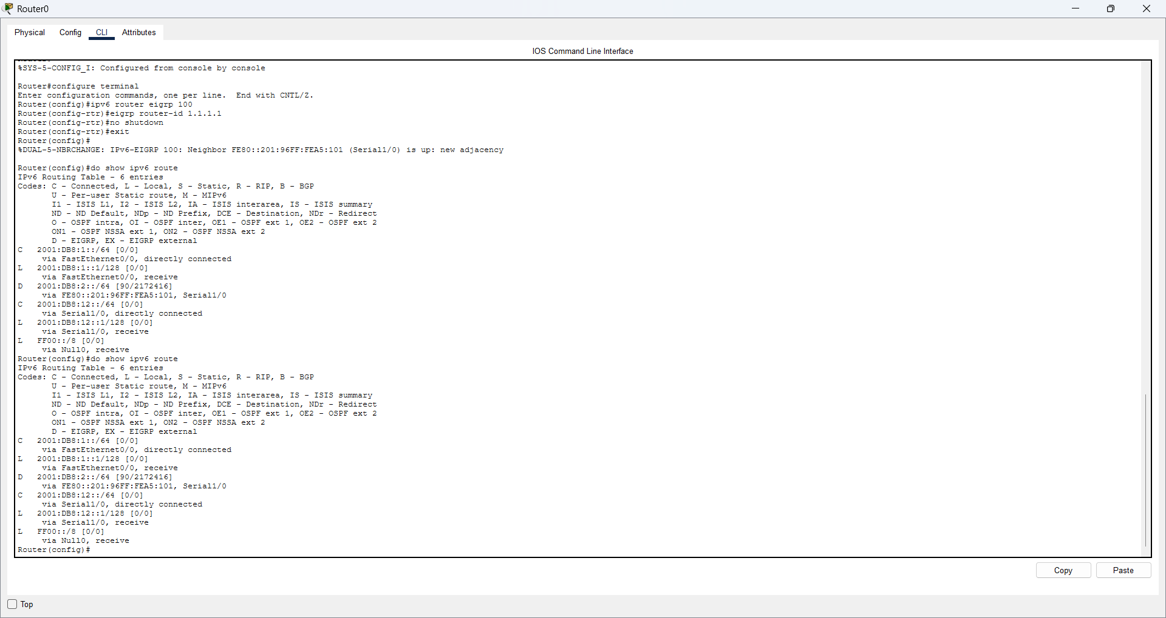
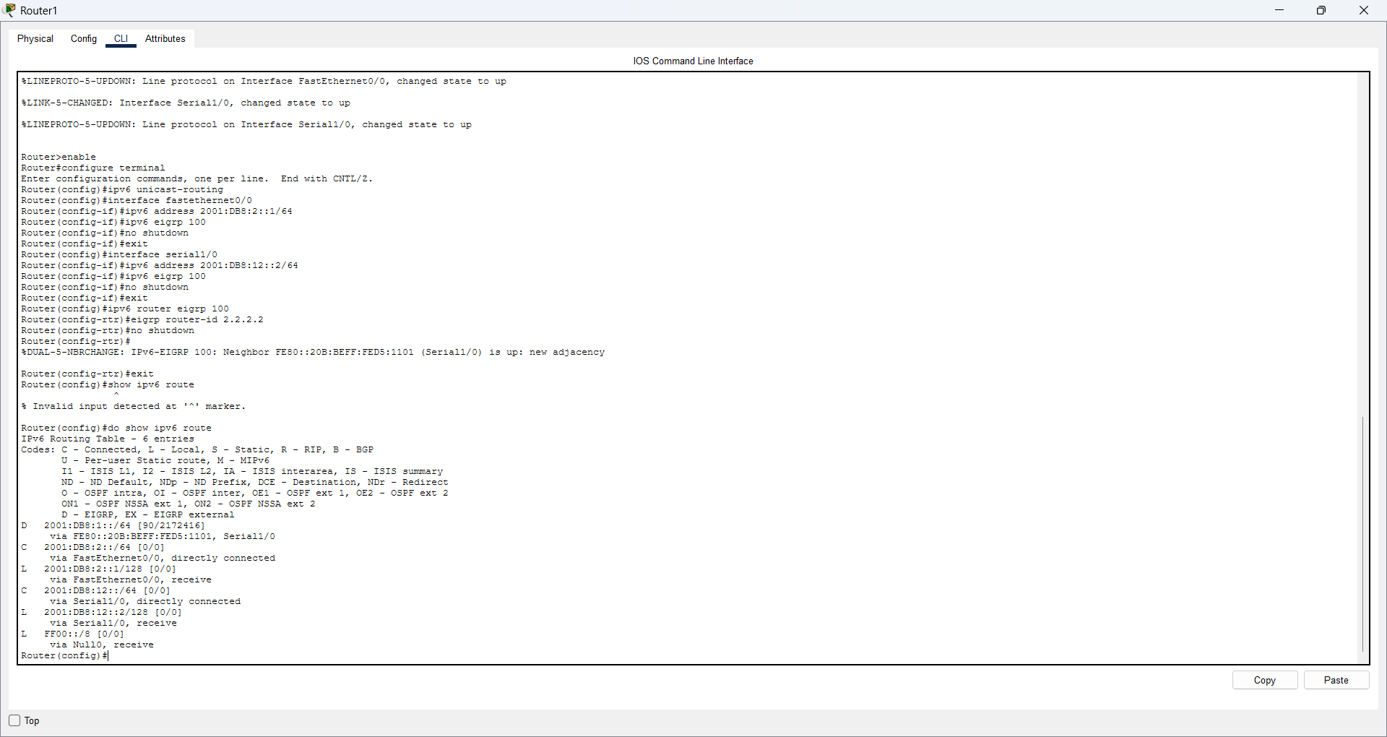
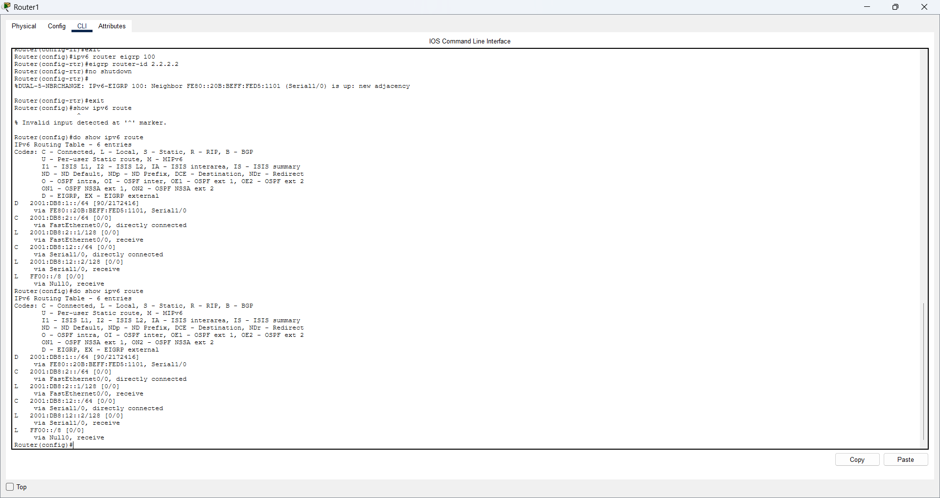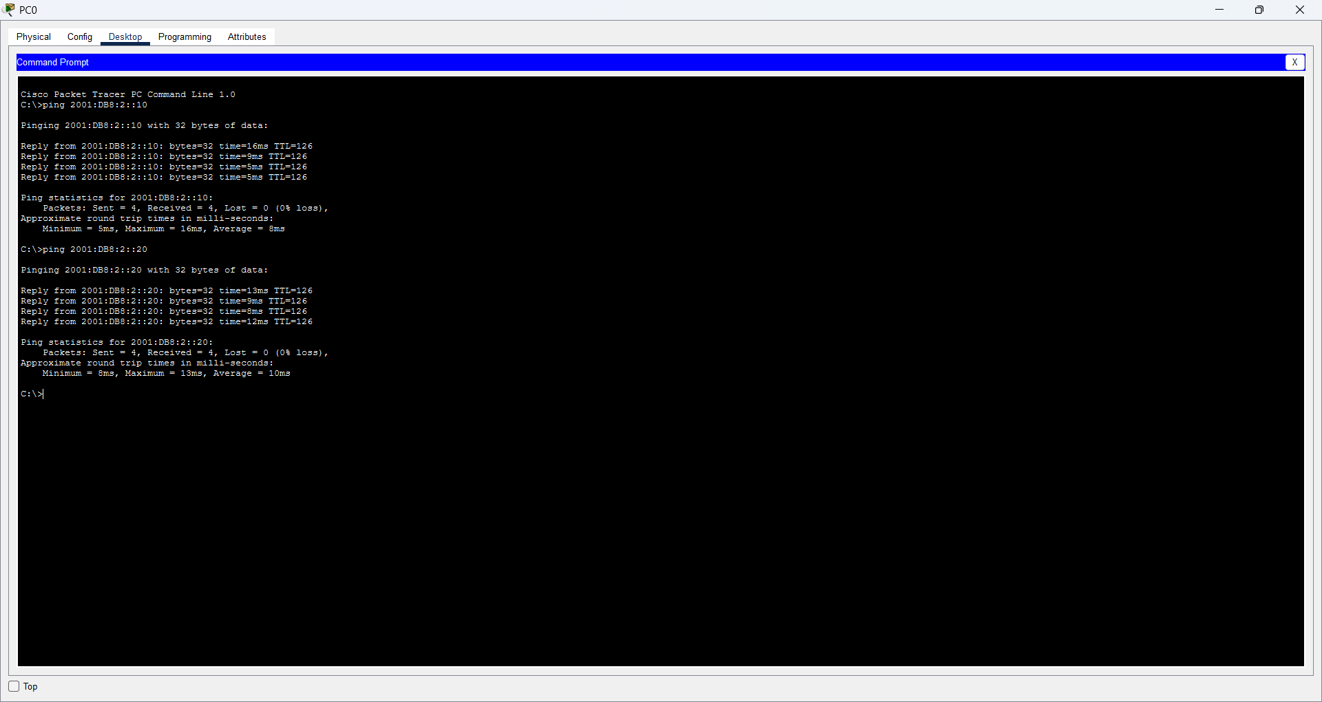

3. OSPFv3 for IPv6
Question: Two routers are connected in a line; each router has two switches, and each switch has two PCs. Configure OSPF. Make the serial interface a backbone area and the FastEthernet ports non-backbone areas with different area numbers. Check whether the PCs can communicate.
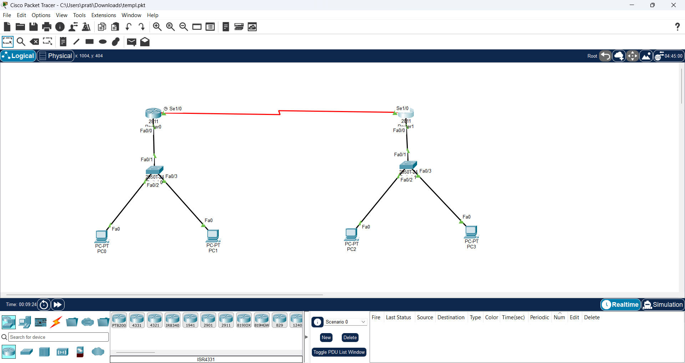

Commands
! Router0
ipv6 unicast-routing
interface fa0/0
ipv6 address 2001:DB8:1::1/64
no shutdown
exit
interface fa0/1
ipv6 address 2001:DB8:2::1/64
no shutdown
exit
interface se1/0
ipv6 address 2001:DB8:12::1/64
clock rate 64000
no shutdown
exit
ipv6 router ospf 1
router-id 1.1.1.1
exit
interface fa0/0
ipv6 ospf 1 area 1
exit
interface fa0/1
ipv6 ospf 1 area 2
exit
interface se1/0
ipv6 ospf 1 area 0
exit
! Router1
ipv6 unicast-routing
interface fa0/0
ipv6 address 2001:DB8:3::1/64
no shutdown
exit
interface fa0/1
ipv6 address 2001:DB8:4::1/64
no shutdown
exit
interface se1/0
ipv6 address 2001:DB8:12::2/64
no shutdown
exit
ipv6 router ospf 1
router-id 2.2.2.2
exit
interface fa0/0
ipv6 ospf 1 area 3
exit
interface fa0/1
ipv6 ospf 1 area 4
exit
interface se1/0
ipv6 ospf 1 area 0
exit
end
write
Check / Test
show ipv6 interface brief
show ipv6 ospf neighbor
show ipv6 ospf interface
show ipv6 route
! Serial1/0 must be Area 0 on both routers.
! Each FastEthernet LAN must have a different non-backbone area.
! From PC0:
ping 2001:DB8:3::10
ping 2001:DB8:4::10

Screenshot
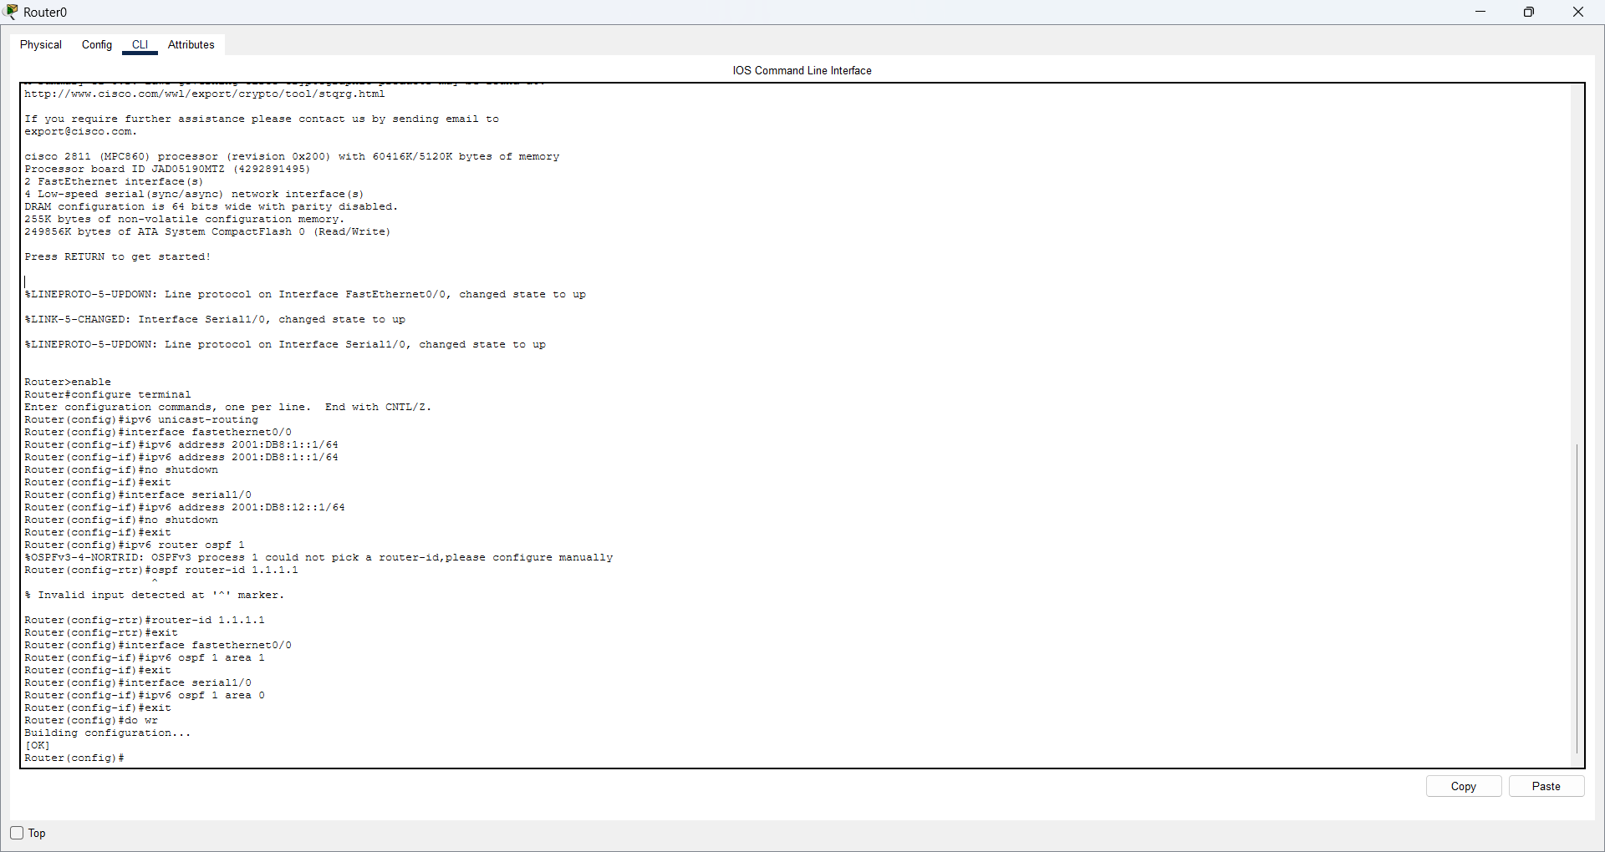
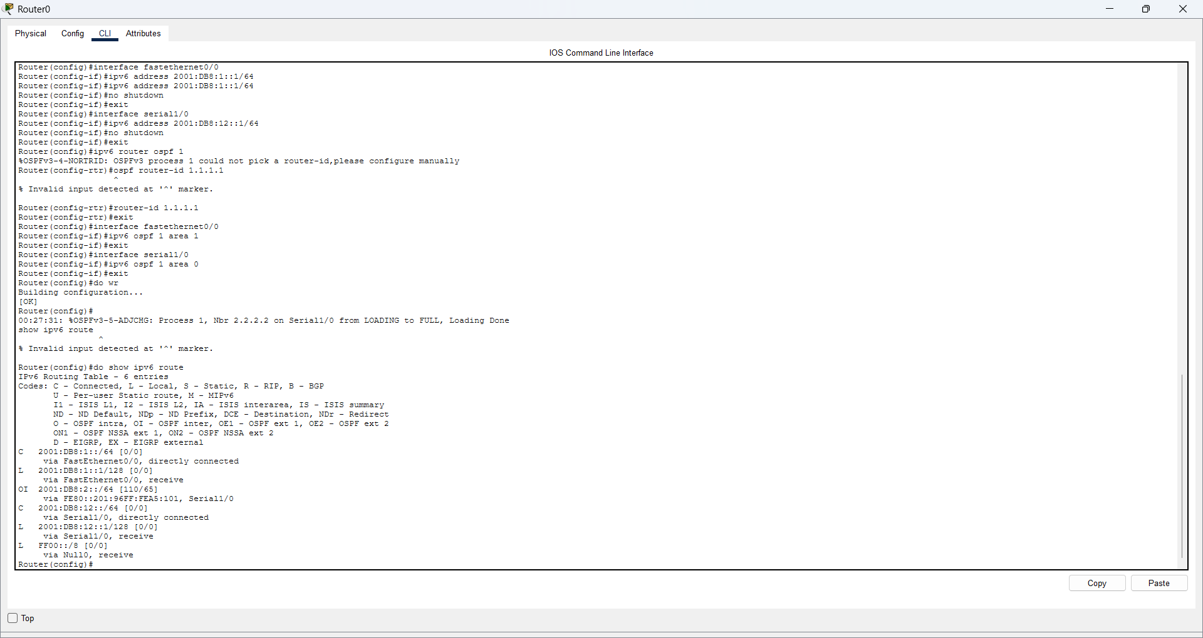
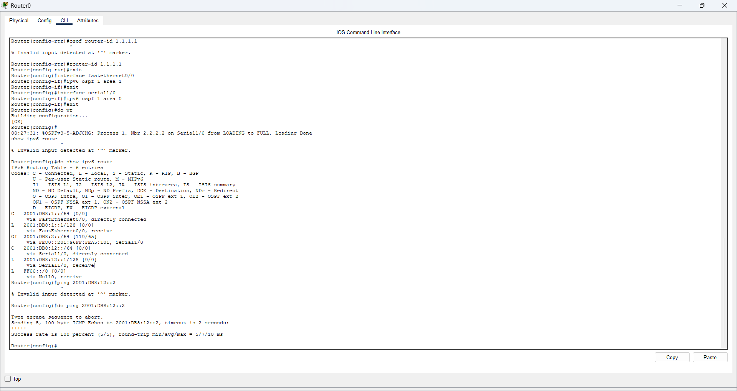
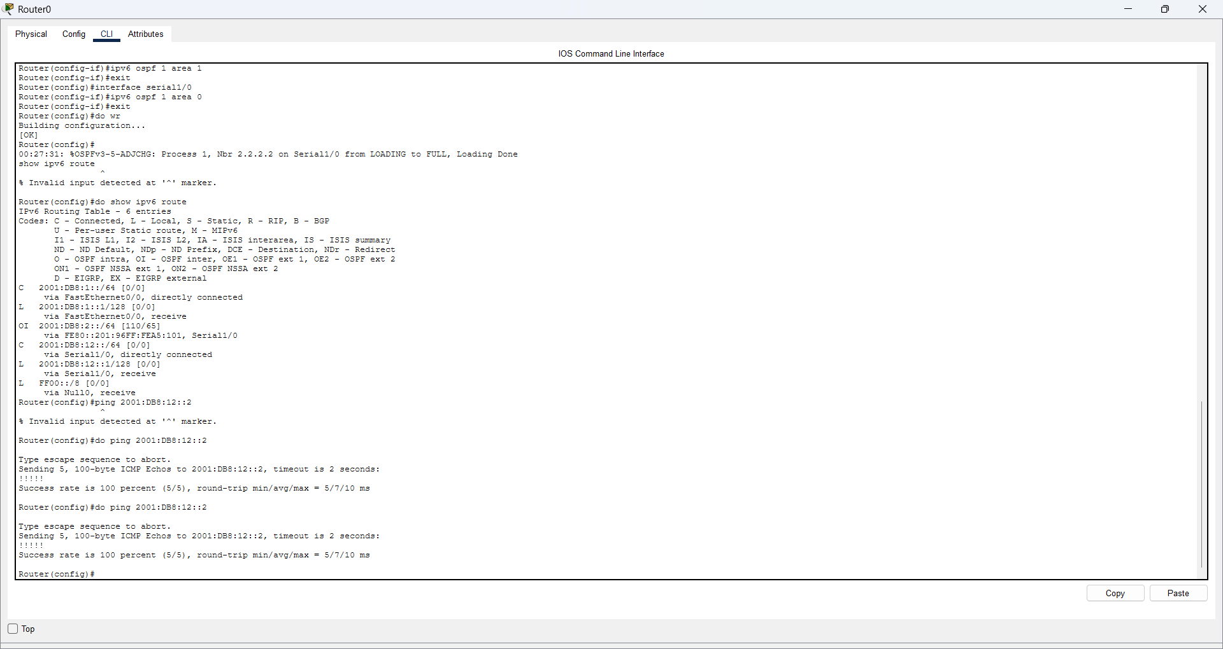
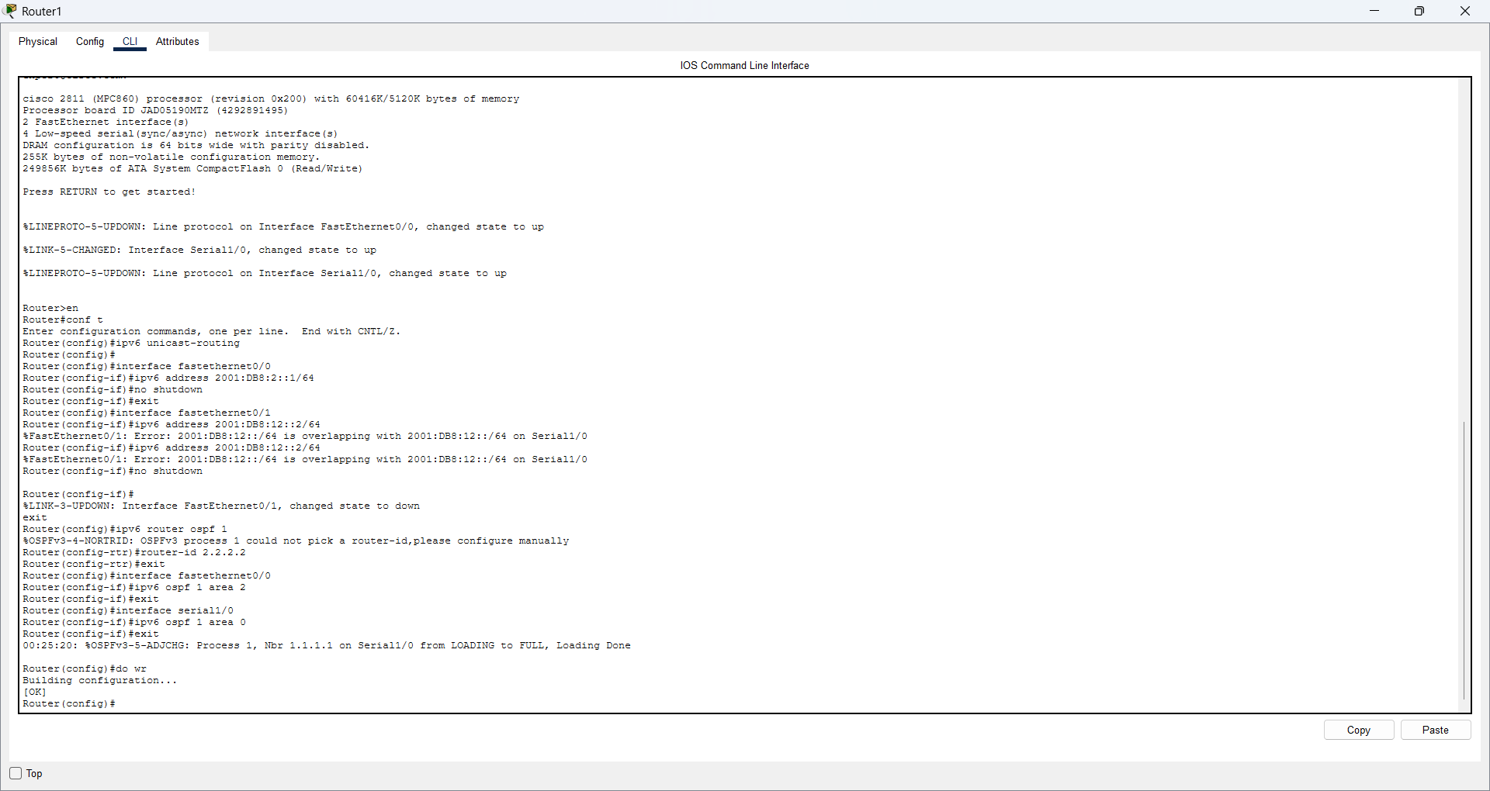
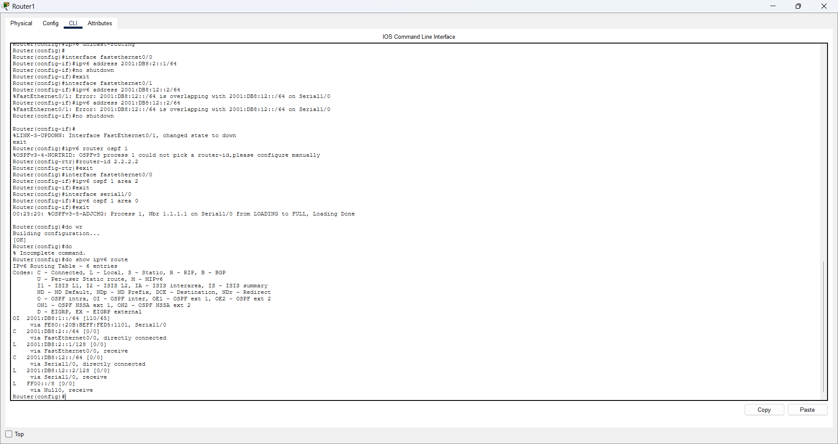
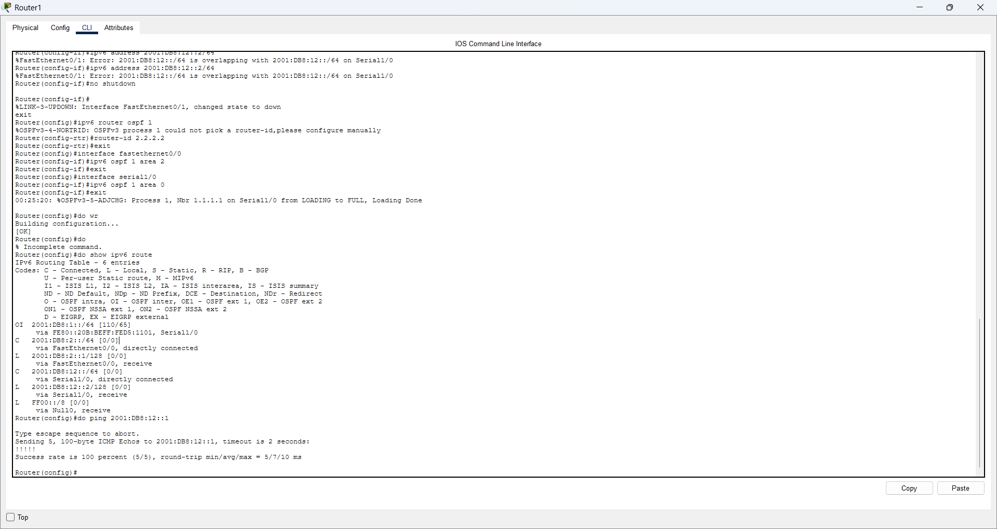
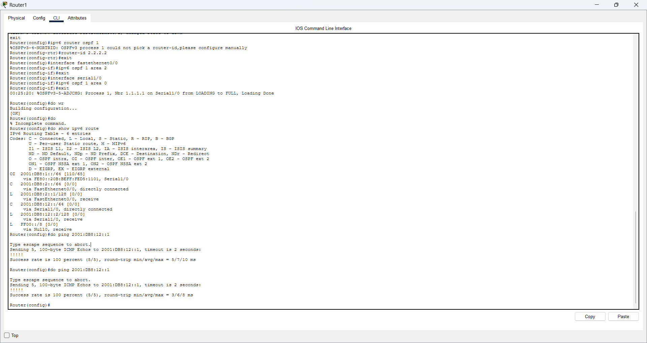
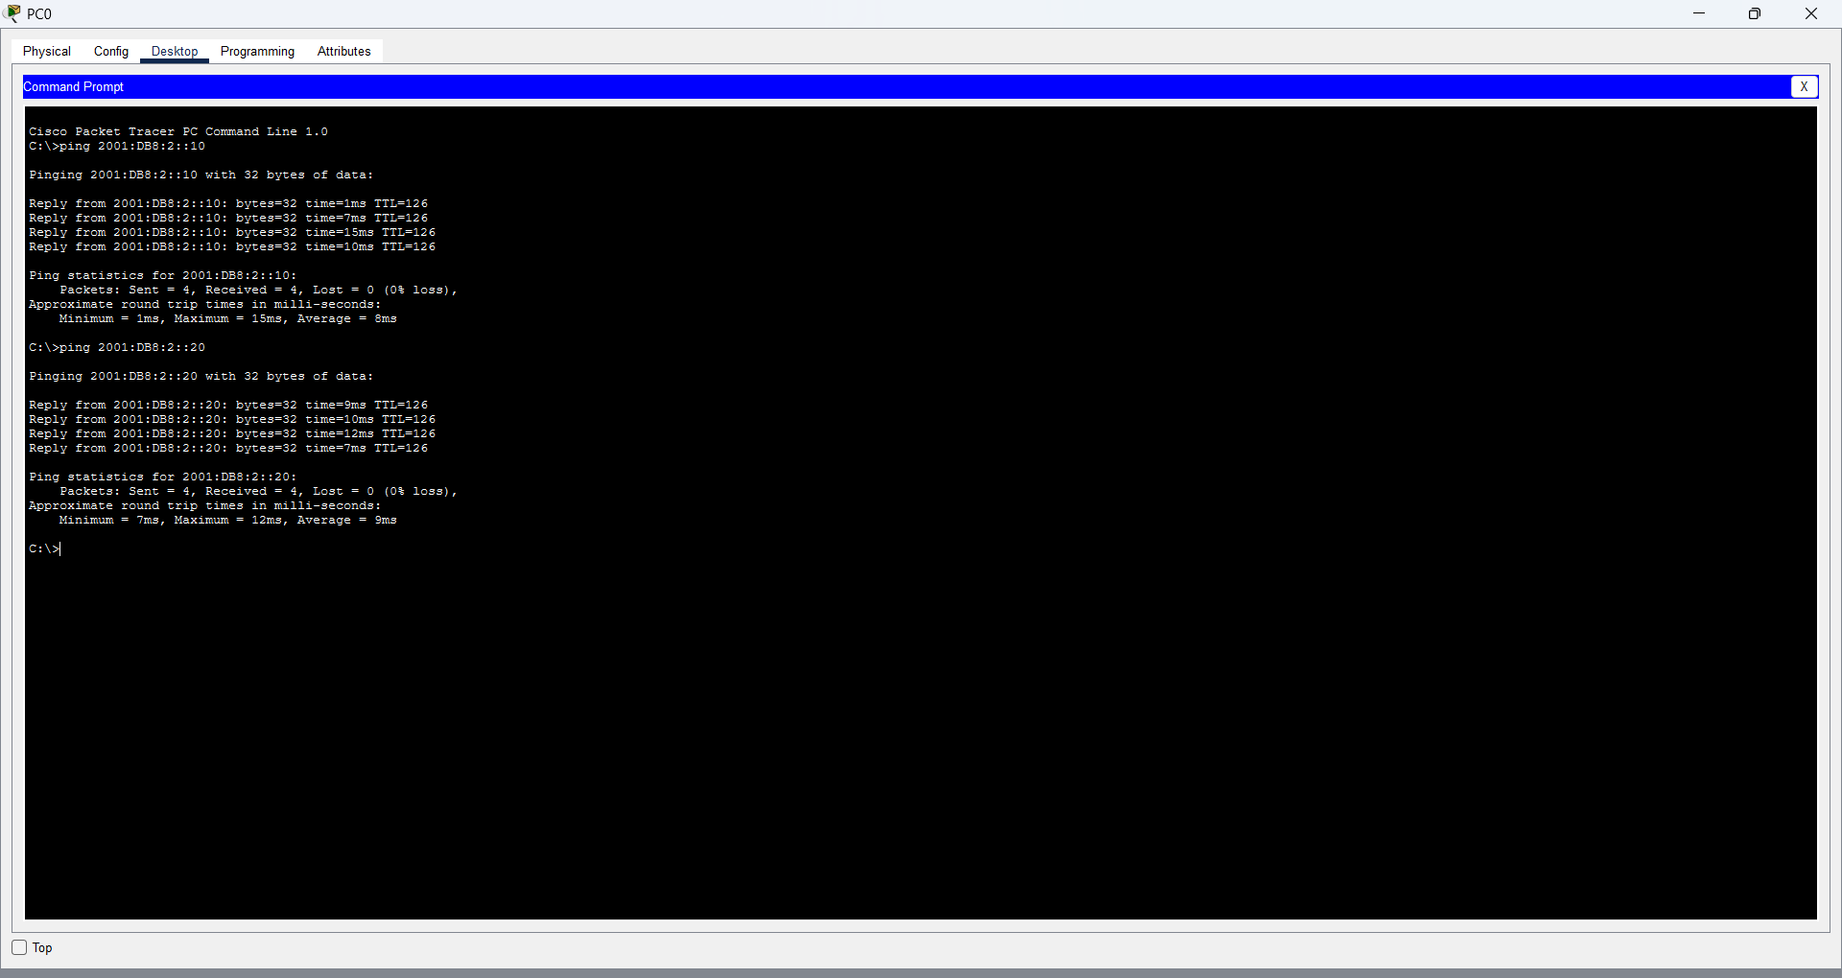

PNR: 260740150018
Name: PRATIK SUNIL ABHANG

Question 1: VLAN
Configure VLAN 10 and VLAN 20 on Switch1
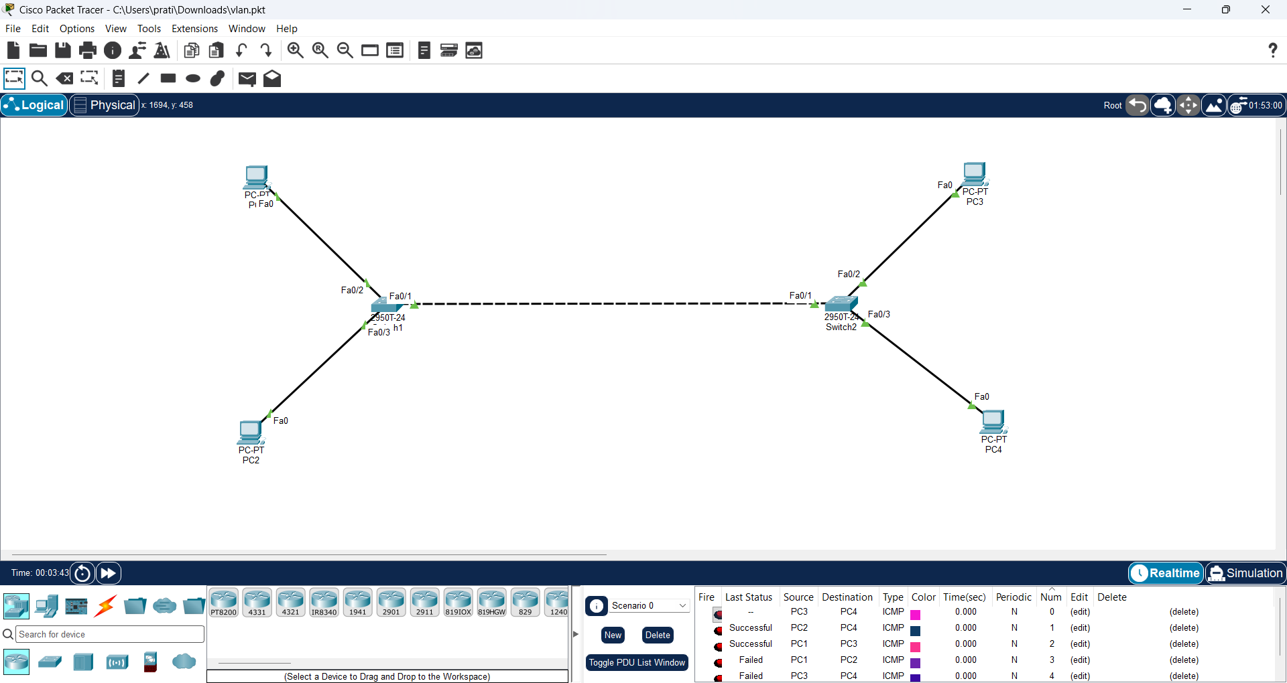

Commands:
enable
configure terminal
vlan 10
name a
exit
vlan 20
name b
exit
interface fa0/2
switchport mode access
switchport access vlan 10
exit
interface fa0/3
switchport mode access
switchport access vlan 20
end
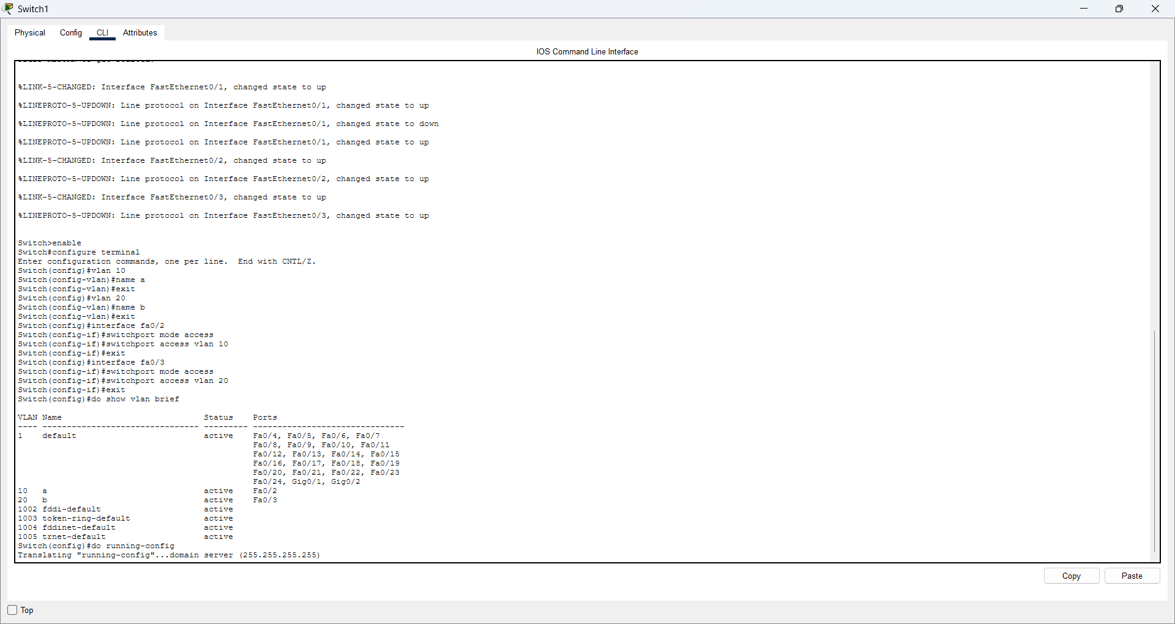

Configure VLAN 10 and VLAN 20 on Switch2
Objective: Create the same VLANs and assign the PC ports.
Commands:
enable
configure terminal
vlan 10
name a
exit
vlan 20
name b
exit
interface fa0/2
switchport mode access
switchport access vlan 10
exit
interface fa0/3
switchport mode access
switchport access vlan 20
end
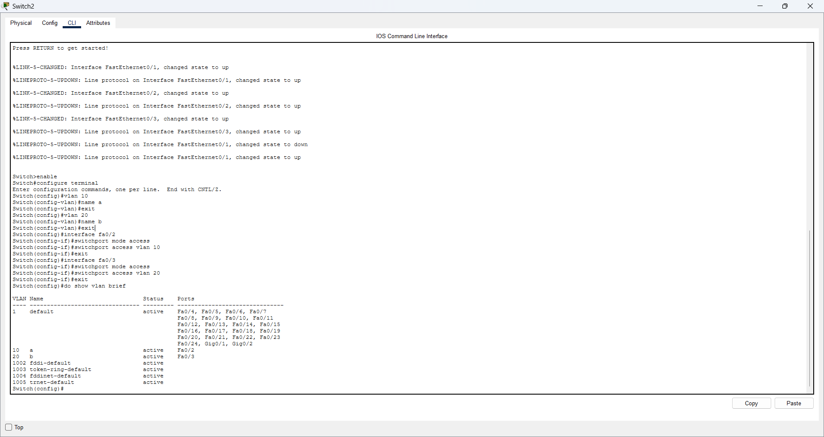

Configure PC IP addresses and test VLAN communication
Commands:
PC1 (VLAN 10): 192.168.10.10 / 255.255.255.0
PC2 (VLAN 20): 192.168.20.10 / 255.255.255.0
PC3 (VLAN 10): 192.168.10.20 / 255.255.255.0
PC4 (VLAN 20): 192.168.20.20 / 255.255.255.0
From PC1 Command Prompt:
ping 192.168.10.20 ← should work (same VLAN)
ping 192.168.20.20 ← should fail (different VLAN, no router)
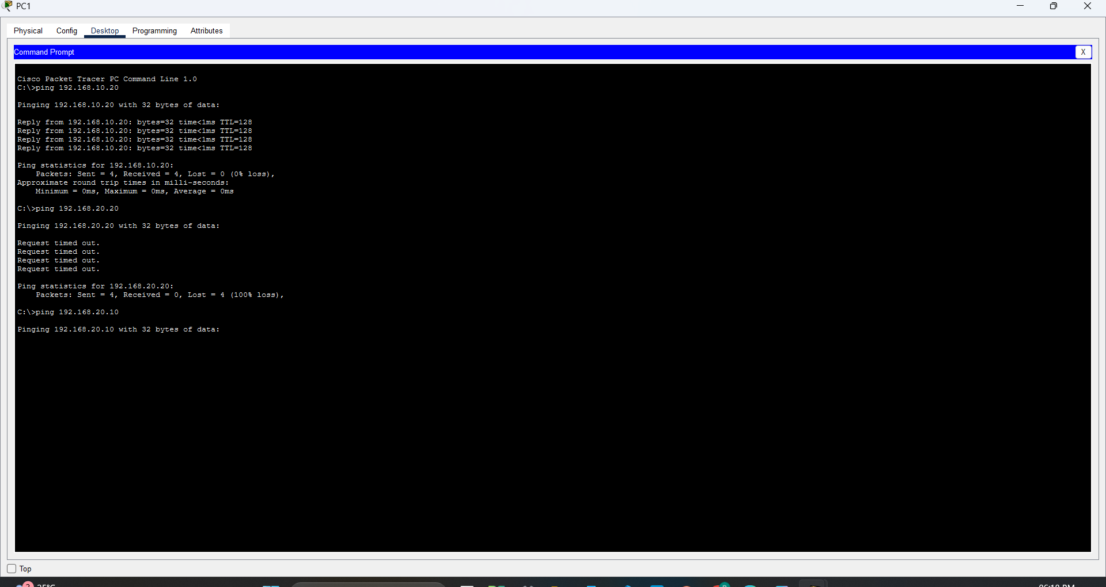

Question 2: VTP
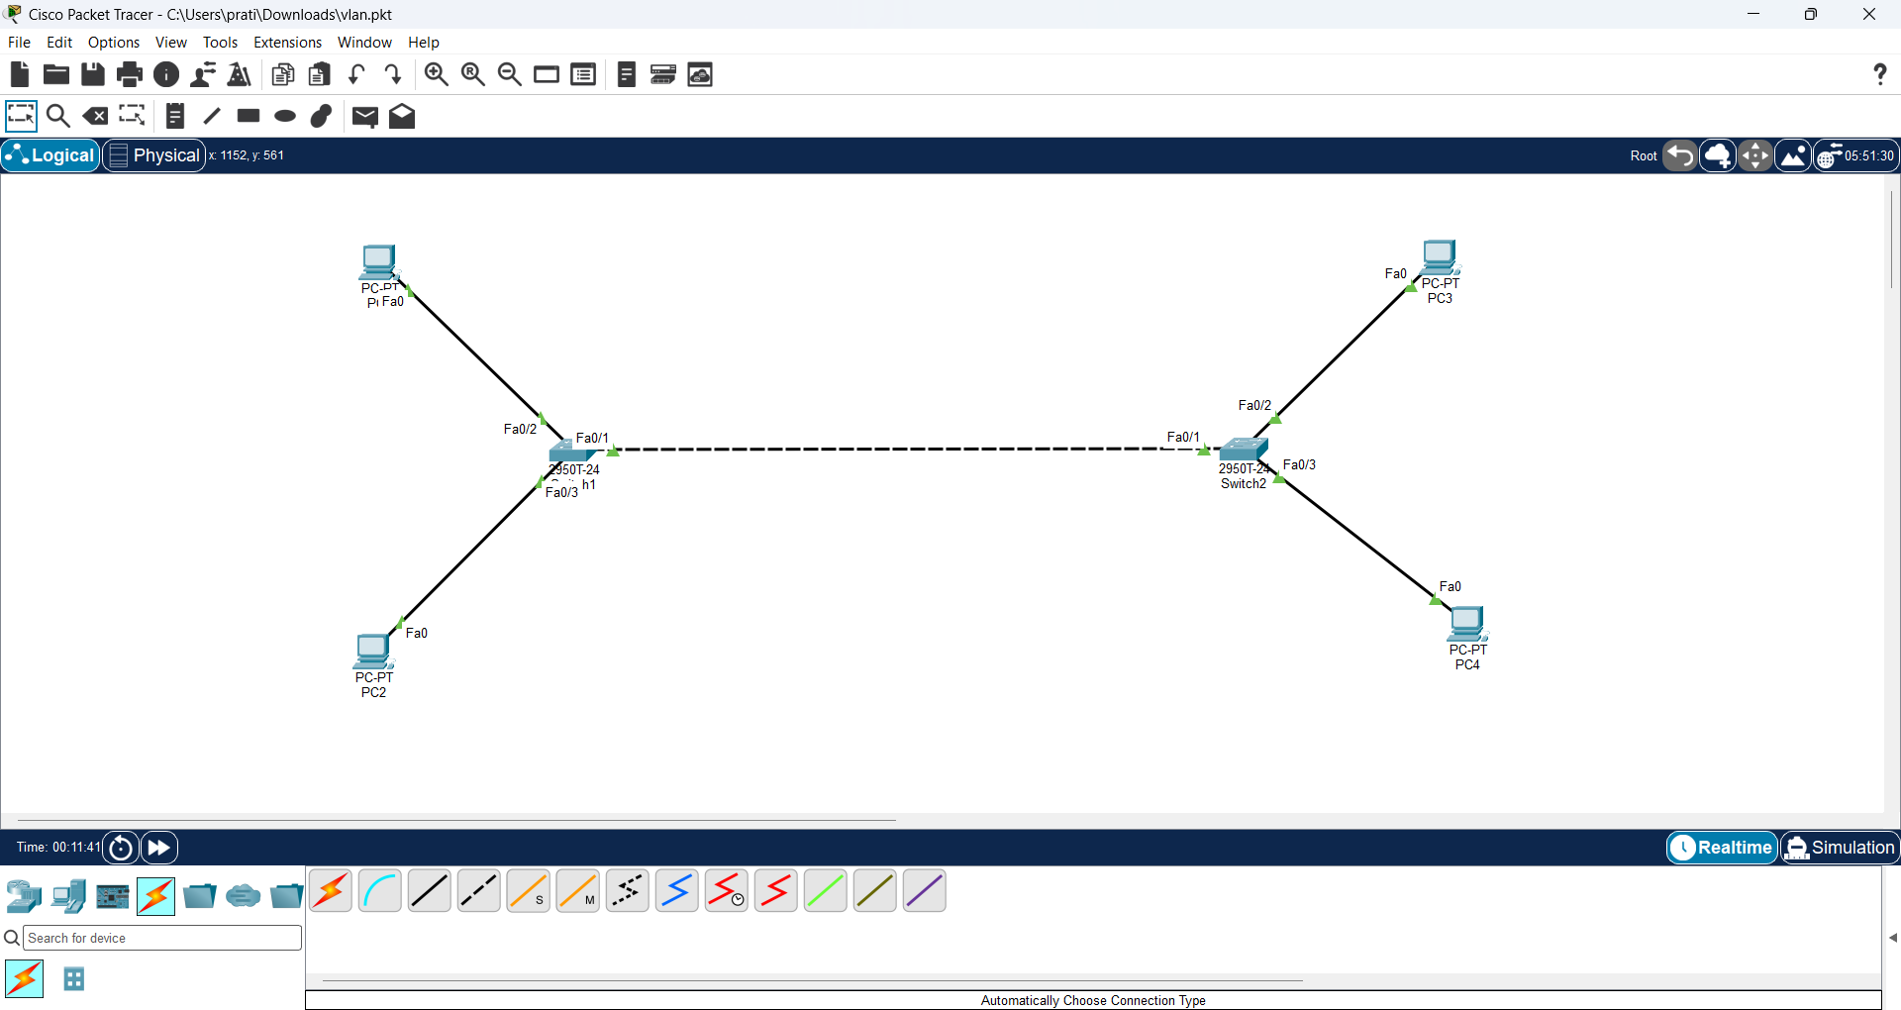
Configure VTP Server and trunk on Switch1
Commands:
enable
configure terminal
interface fa0/1
switchport mode trunk
switchport trunk allowed vlan 10,20
exit
vtp domain company
vtp mode server
vlan 10
name a
exit
vlan 20
name b
exit
end
show vtp status
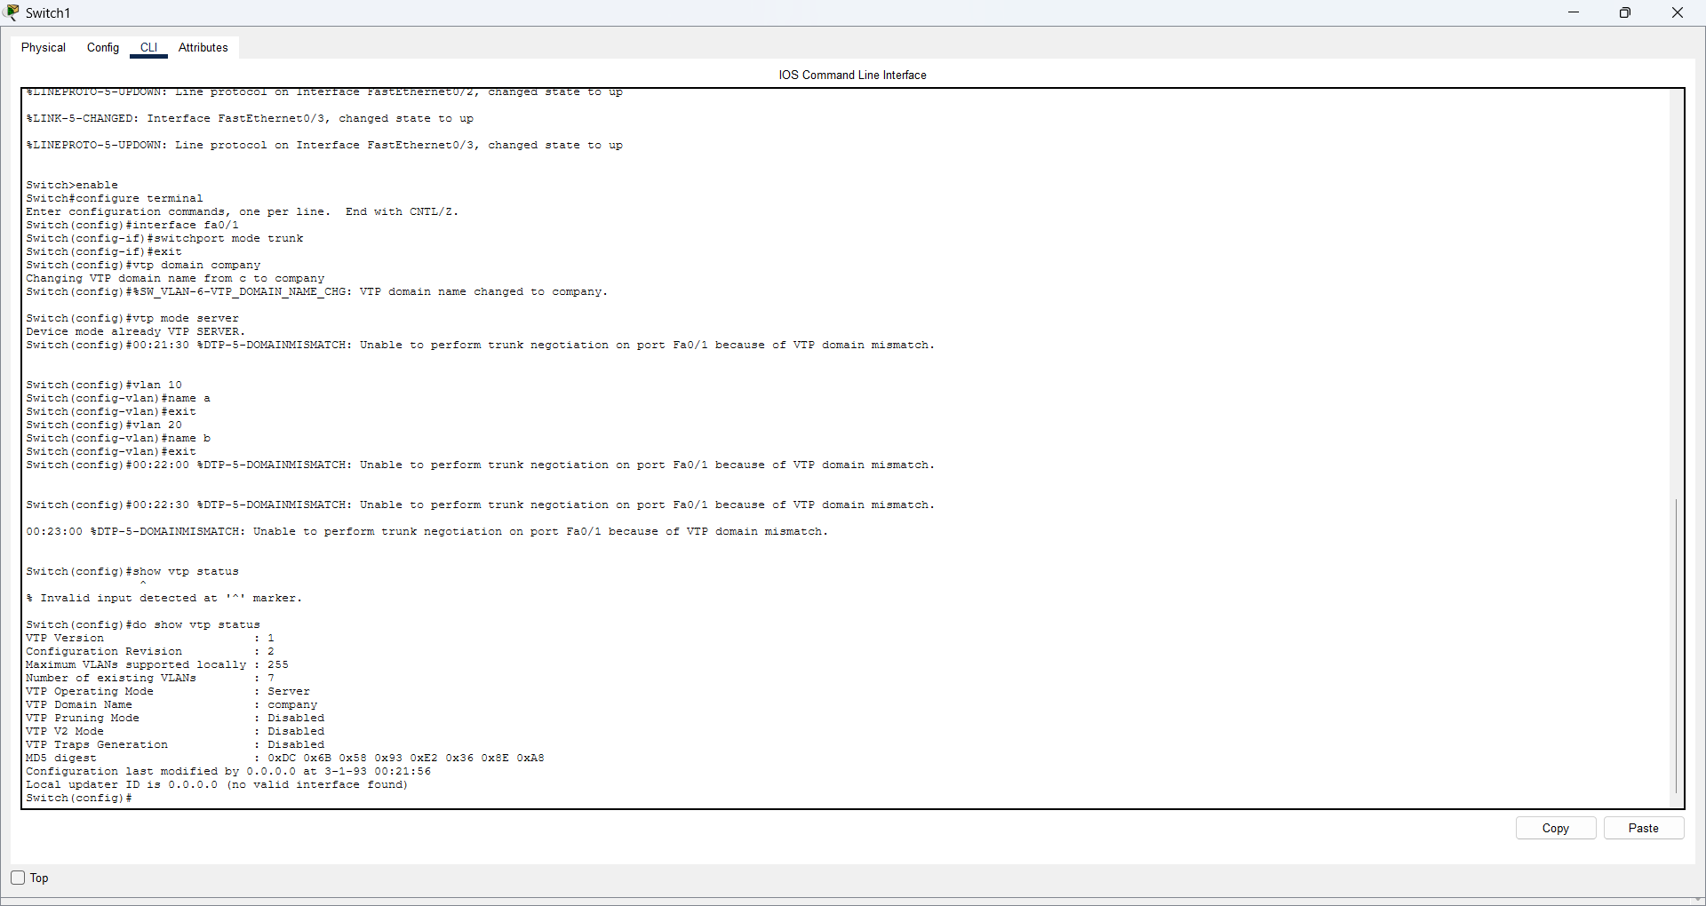

Configure VTP Client on Switch2
Commands:
enable
configure terminal
interface fa0/1
switchport mode trunk
switchport trunk allowed vlan 10,20
exit
vtp domain company
vtp mode client
end
show vtp status
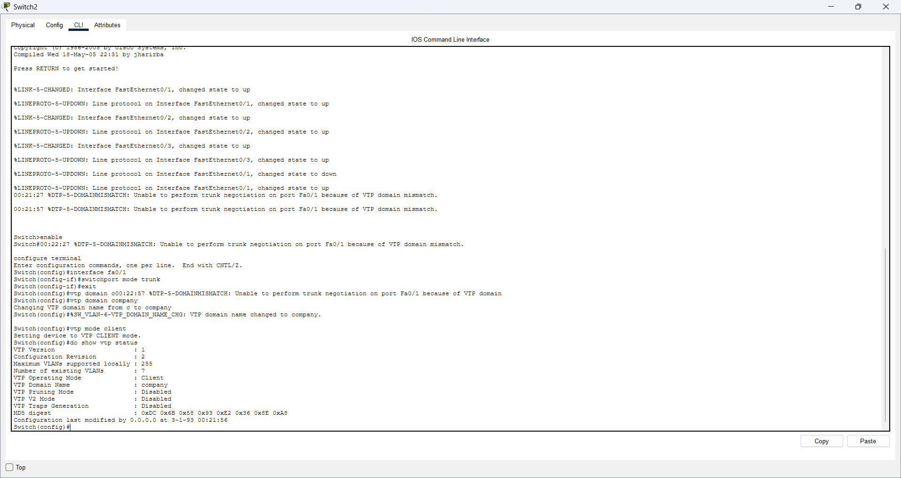
.

Question 7: Verify VTP configuration
Objective: Check that the VTP mode and domain name are correct and that the VLAN information is available.
Commands:
show vtp status
show vlan brief
show interfaces trunk
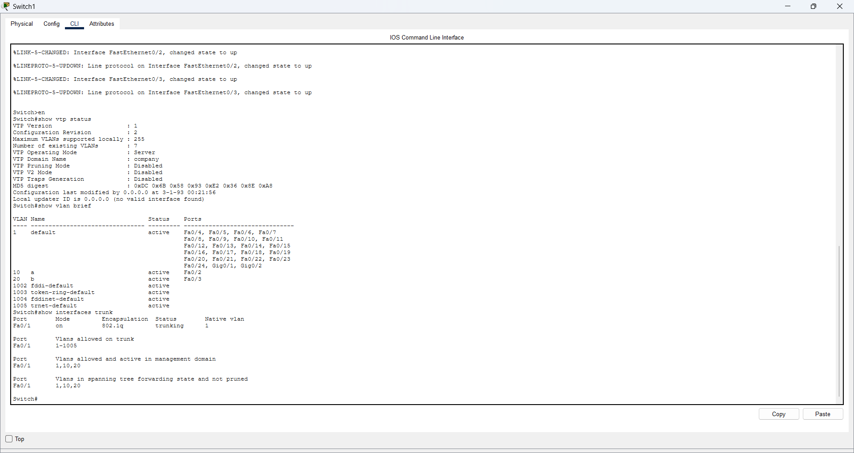

Question 3: STP
Create the STP topology
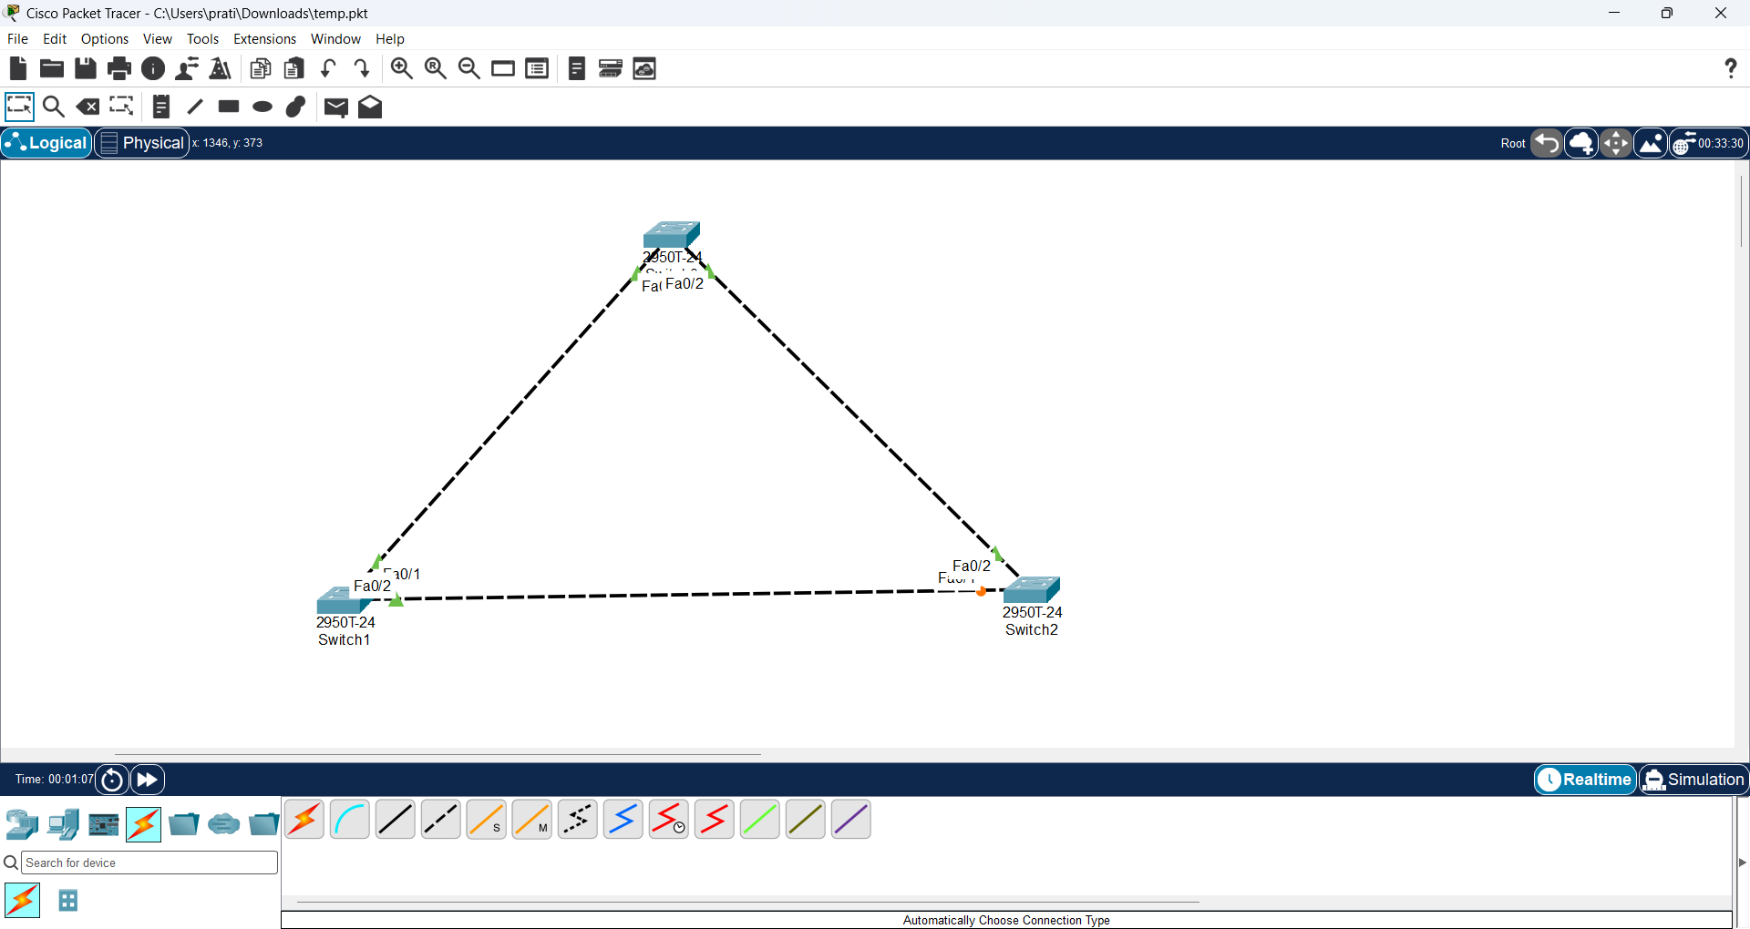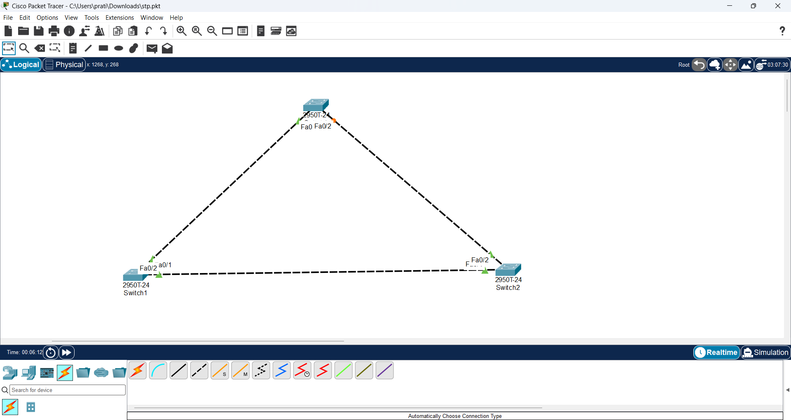

Configure Switch1 as the STP Root Bridge
Commands:
enable
configure terminal
spanning-tree vlan 1 priority 4096
end
show spanning-tree
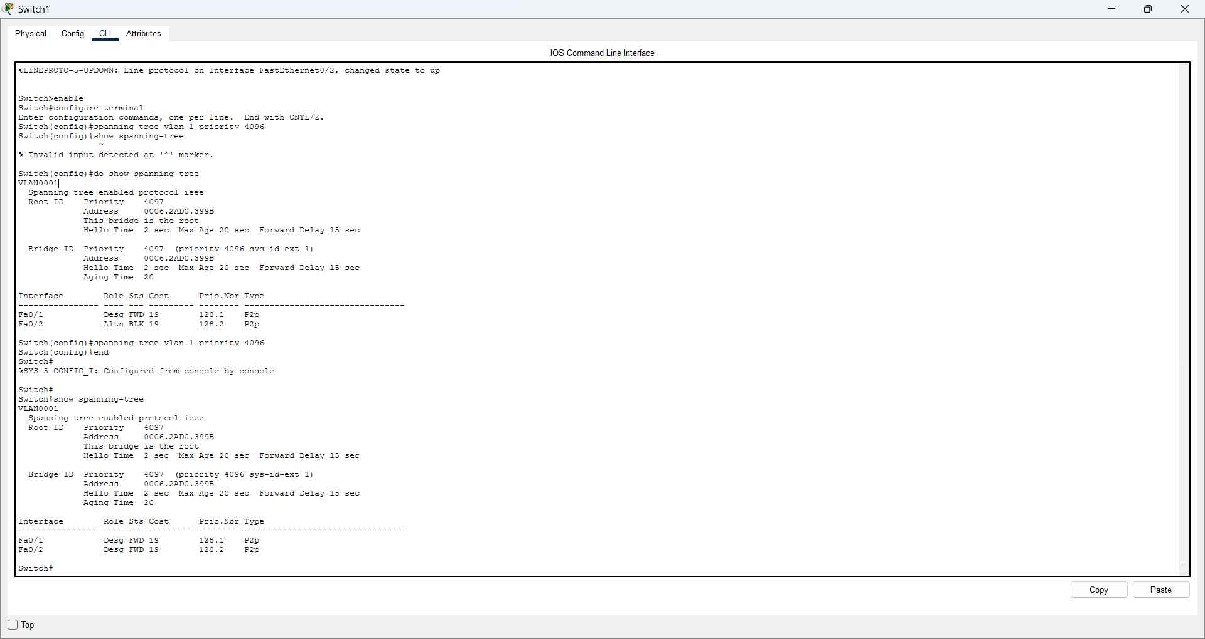

Question 10: Verify the STP result on the switches
Commands:
On each switch:
enable
show spanning-tree

